project-root/

│

├── src/

│ ├── main/

│ │ ├── java/

│ │ │ ├── base/ # WebDriver, Appium, RestAssured setup

│ │ │ ├── config/ # Property reader, environment config

│ │ │ ├── utils/ # Reusable utility classes (Excel, JSON, waits)

│ │ │ ├── pojo/ # POJO classes for API payloads

│ │ │ ├── api/ # API request classes (RestAssured)

│ │ │ ├── web/pages/ # Page Object Model classes (Selenium)

│ │ │ ├── android/pages/ # Android screen objects (Appium)

│ │ │ └── android/utils/ # Mobile-specific utilities

│ │ └── resources/

│ │ ├── config.properties # Base URLs, credentials, etc.

│ │ └── testdata/ # JSON/XML/Excel files

│

├── src/

│ ├── test/

│ │ ├── java/

│ │ │ ├── api/tests/ # API test classes

│ │ │ ├── web/tests/ # Web test classes

│ │ │ ├── android/tests/ # Android test classes

│ │ │ └── testng/ # TestNG runners, listeners

│ └── resources/

│ └── testng.xml # Master suite config

│

├── reports/ # Extent/Allure reports

├── logs/ # Execution logs

├── screenshots/ # Failure screenshots

├── pom.xml # Maven dependencies

└── README.md # Project overview

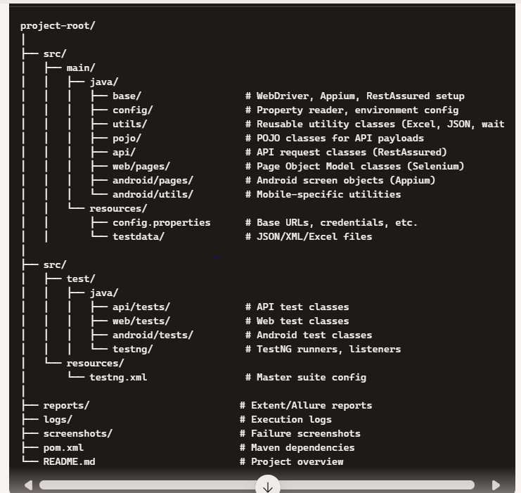

**✅ base/**

* **Purpose:** Common setup classes jo har test ke liye reuse honge.
* **Classes:**
  + ApiBase.java → RestAssured base URI, headers setup
  + WebBase.java → Selenium WebDriver init, browser config
  + AndroidBase.java → Appium driver init, capabilities setup

### ✅ config/

* **Purpose:** Environment aur property management.
* **Classes:**
  + ConfigReader.java → config.properties file read karne ke liye
  + EnvironmentManager.java → QA/DEV/PROD environment switch karne ke liye

### ✅ utils/

* **Purpose:** Reusable helper classes.
* **Classes:**
  + ApiUtils.java → Common RestAssured methods (print response, status check)
  + ExcelUtils.java → Test data read/write from Excel
  + JsonUtils.java → JSON parse/compare
  + WaitUtils.java → Selenium explicit waits
  + ScreenshotUtils.java → Failure screenshots

### ✅ pojo/

* **Purpose:** API request/response mapping.
* **Classes:**
  + RegisterPOJO.java → Register API body
  + CreatePasswordPOJO.java → Create Password API body
  + LoginPOJO.java → Login API body
  + Response POJOs → For deserializing API responses

### ✅ api/

* **Purpose:** Modular API request builders.
* **Classes:**
  + UserApi.java → Register, Create Password, Login endpoints
  + AccountApi.java → FD/RD related endpoints
  + ApiValidator.java → Response validation methods

### ✅ web/pages/

* **Purpose:** Page Object Model (POM) for website testing.
* **Classes:**
  + LoginPage.java → locators + actions for login
  + DashboardPage.java → locators + actions for dashboard
  + FDPage.java → FD creation flow

### ✅ android/pages/

* **Purpose:** Appium screen objects for Android app.
* **Classes:**
  + LoginScreen.java → Mobile locators + actions
  + DashboardScreen.java → Mobile locators + actions
  + FDFlowScreen.java → FD flow on mobile

### ✅ android/utils/

* **Purpose:** Mobile‑specific helpers.
* **Classes:**
  + MobileActions.java → Tap, swipe, scroll methods
  + AppUtils.java → App install/uninstall, reset methods

### ✅ testng/

* **Purpose:** TestNG specific classes.
* **Classes:**
  + Listeners.java → OnTestFailure screenshot, logging
  + RetryAnalyzer.java → Retry failed tests
  + SuiteRunner.java → Custom suite execution

### ✅ api/tests/

* **Purpose:** API test cases.
* **Classes:**
  + RegisterTest.java
  + CreatePasswordTest.java
  + LoginTest.java

### ✅ web/tests/

* **Purpose:** Web test cases.
* **Classes:**
  + LoginWebTest.java
  + FDWebTest.java

### ✅ android/tests/

* **Purpose:** Android test cases.
* **Classes:**
  + LoginAndroidTest.java
  + FDAndroidTest.java

### ✨ Shortcut “Shor”

* base → setup classes ✅
* config → env + properties ✅
* utils → helpers ✅
* pojo → API payloads ✅
* api → request builders ✅
* web/pages → Selenium POM ✅
* android/pages → Appium screens ✅
* testng → listeners, retry ✅
* tests → actual test cases ✅

Sample code for understabing of restasured + testing

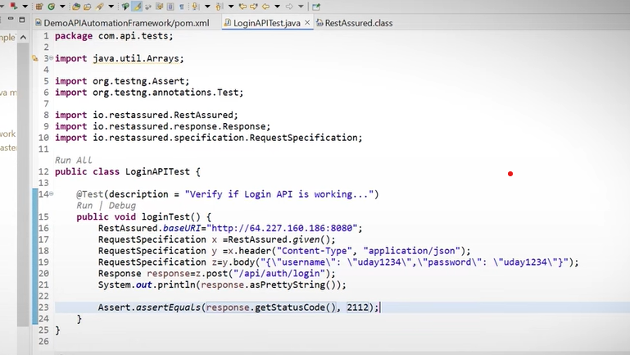

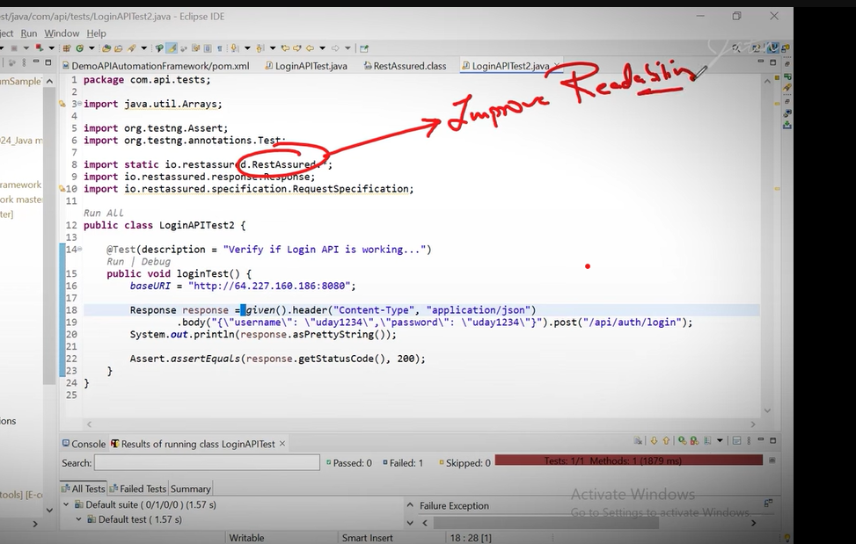

Create new package under test- com.API.Base

Create class BaseService.java

In Baseservice we handle main URI

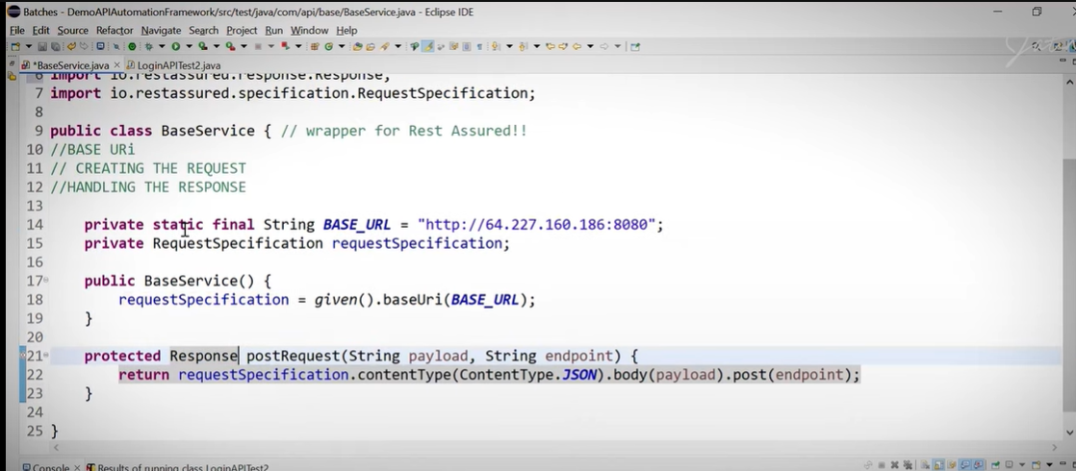

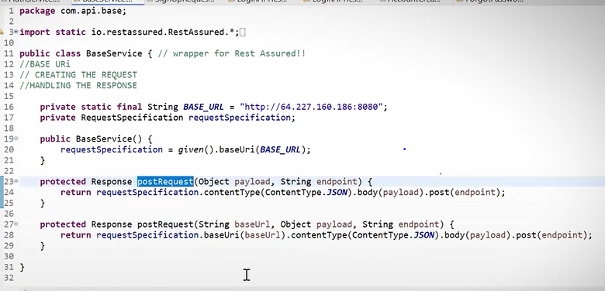

One more class authservice and its extend BaseService Class

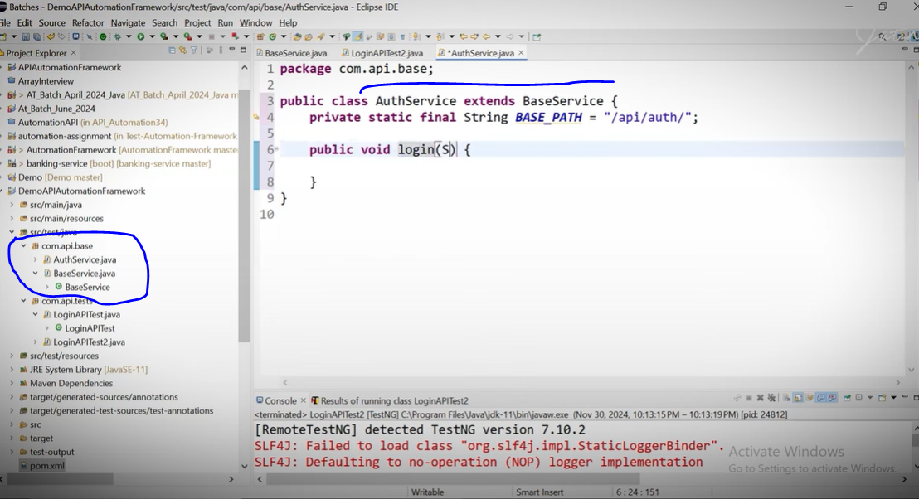

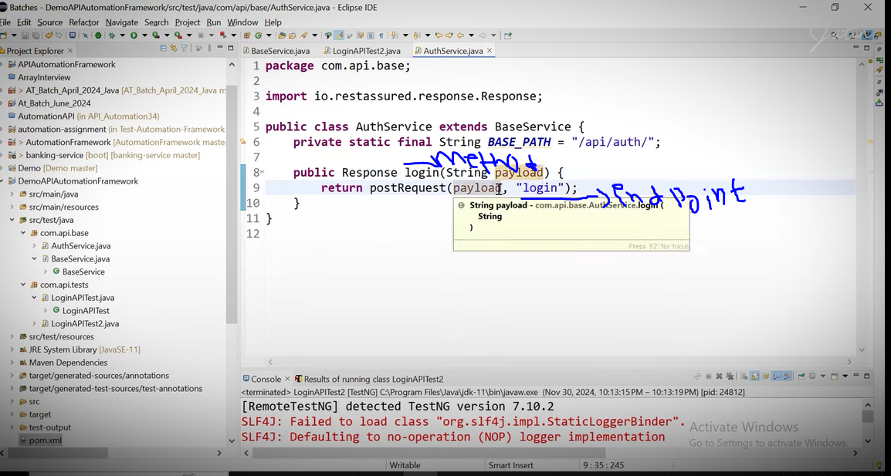

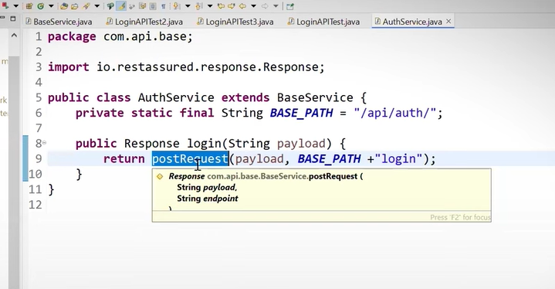

For learning purpose create one more same test class & Run.

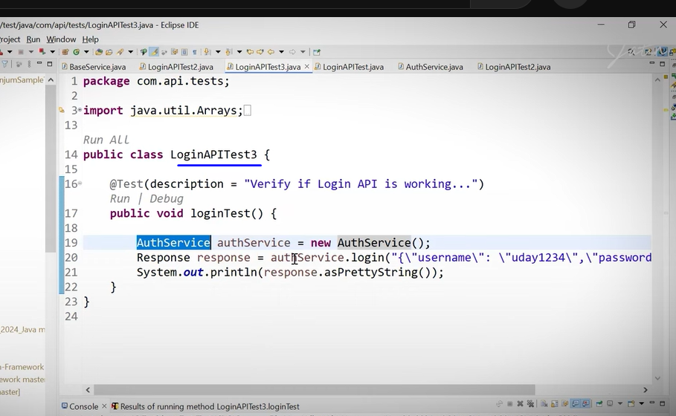

But in above image if u see carefully there is data (username , password) is hardcoded and we have to remove this , so in this case POJO classes are comes, so we are going to create 1 package com.api.models under same src/test/java

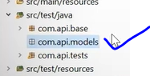

So me create more 2 package for requaet and response

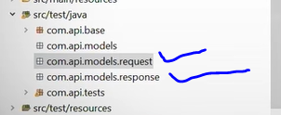

So under models.request package create loginrequest pojo class.

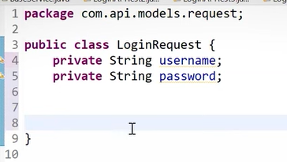

Right click -> go to source -> generate the constructor using the fields

Right click-> go to source -> generate getters & setters

Right click-> go to source -> generate to string() methods

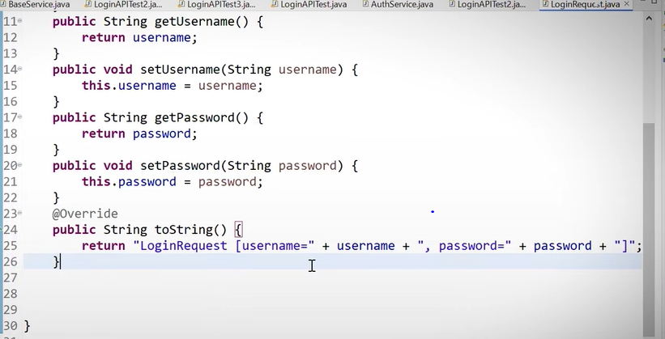

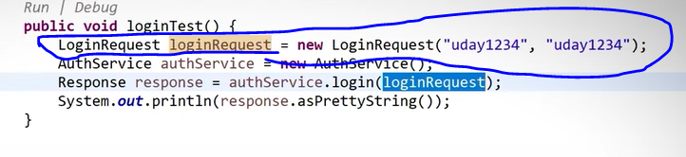

Now we have to change to do change in authservice and Base class , where is word (String , payload) there we have to change as a (loginRequest, Payload). Also we need to add library n pom.xml file

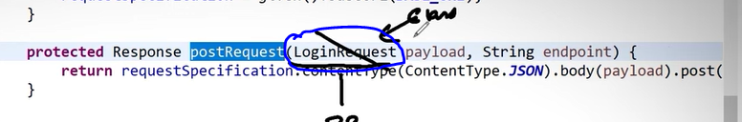

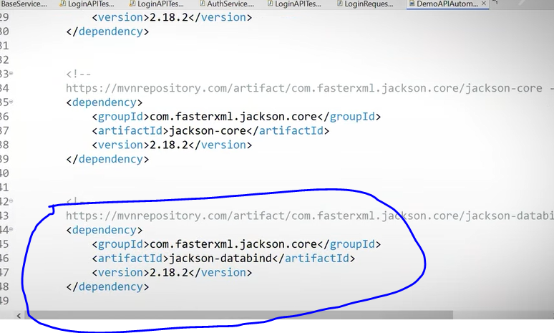

Then run the program, its run. But now here is the problem, we can not send the child class efeence , parent ka reference pass krte hai,

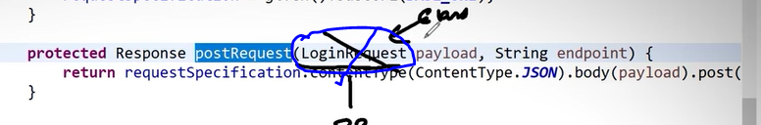

Now do small changes enter ‘Object’ instead of childclass reference

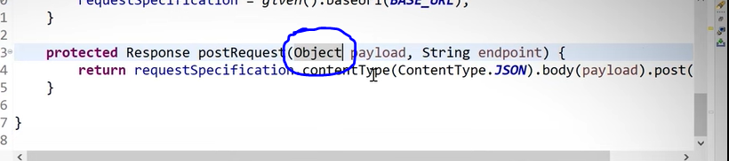

Now we have to deserialize the response hence we need to create a class under the com.api.models.response packacge , cass name – Loginresponse

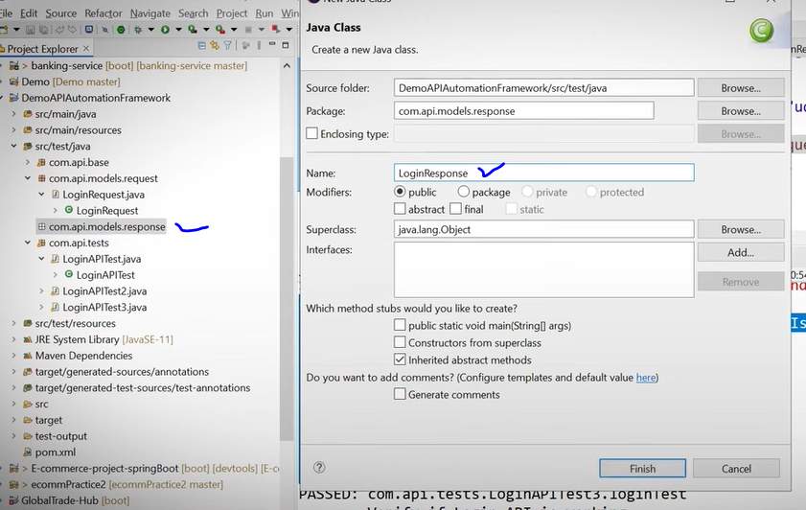

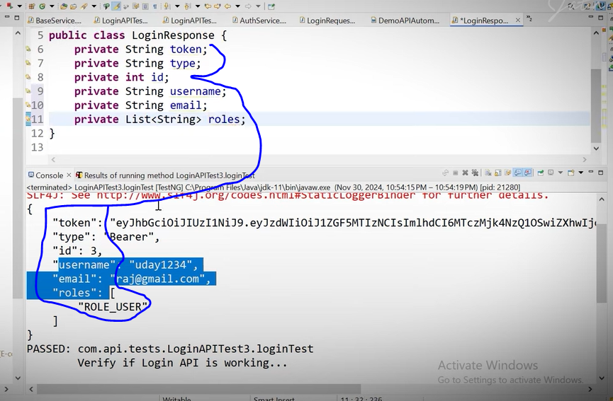

Right click -> go to source -> generate the constructor using the fields

Right click-> go to source -> generate getters & setters

Right click-> go to source -> generate to string() methods.

Add default constructor

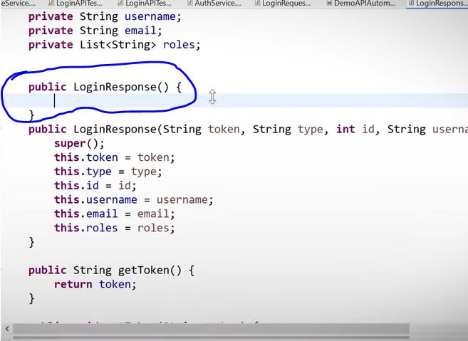

Now go back to the loginrequest3 and

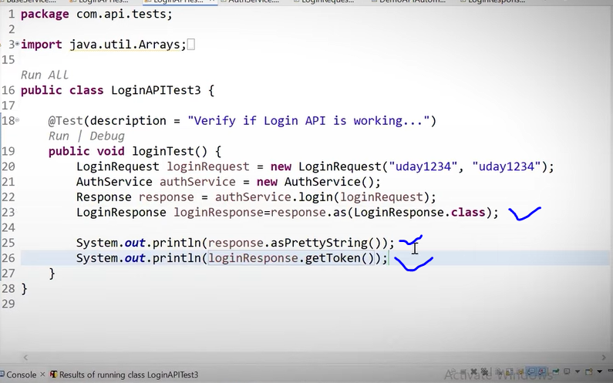

In above image we are printing token from response, we can print any value saparetly from response

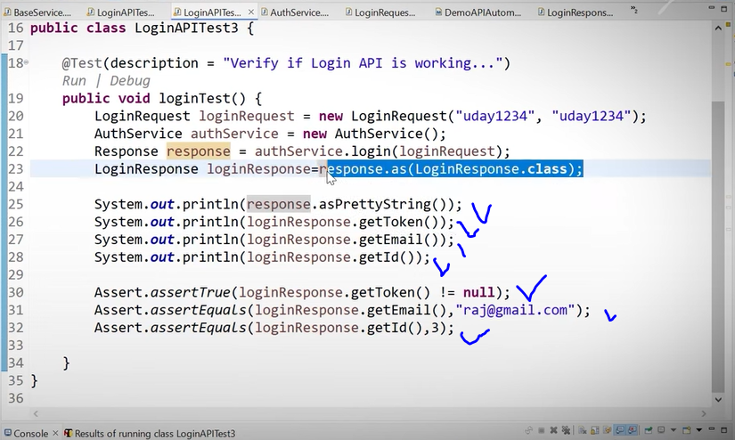

Now we creating the setup/test for signup request

Signup POJO

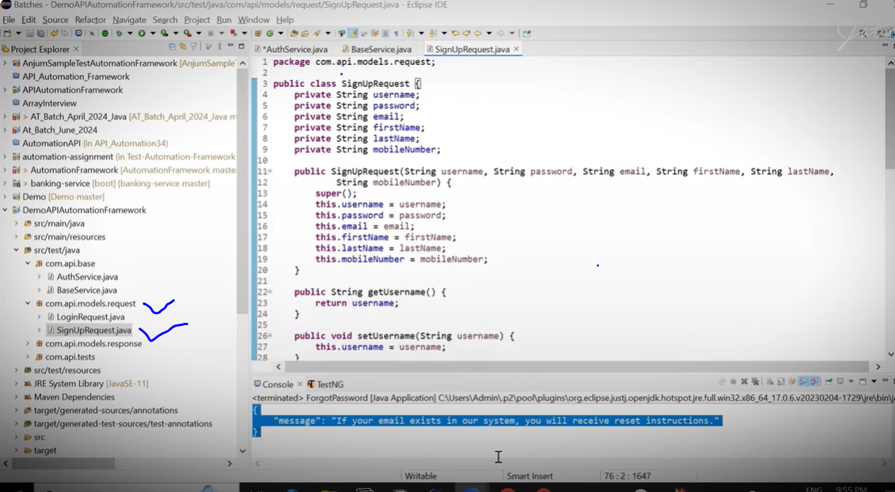

Now we are creating build data design pattern, so for that we are crating inner class under the signup pojos . its help to remember the what data(field) i have to enter

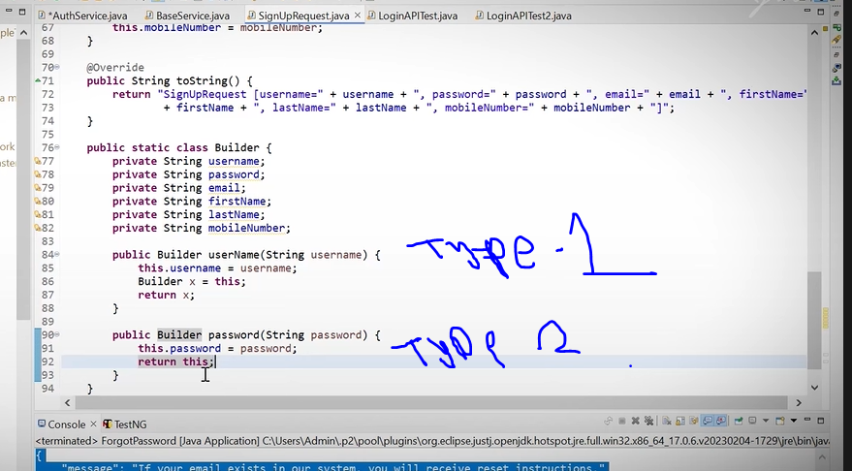

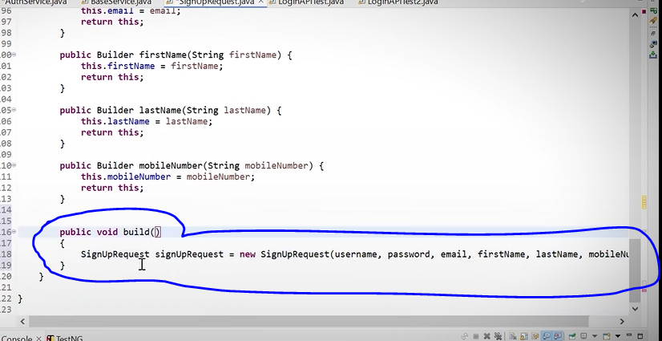

We create above method and method always return something

Updated below

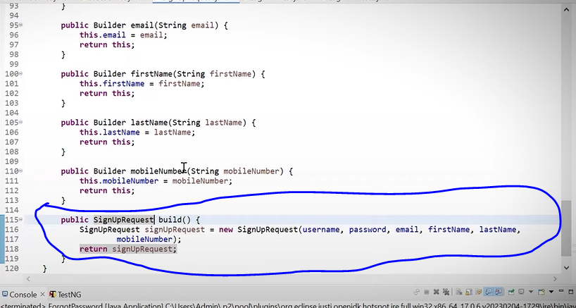

What is benefits of this ?

Benefits is koi bhe cheese ko kidhar bhe lagate jao.

Now Create a AccountCreation test Class

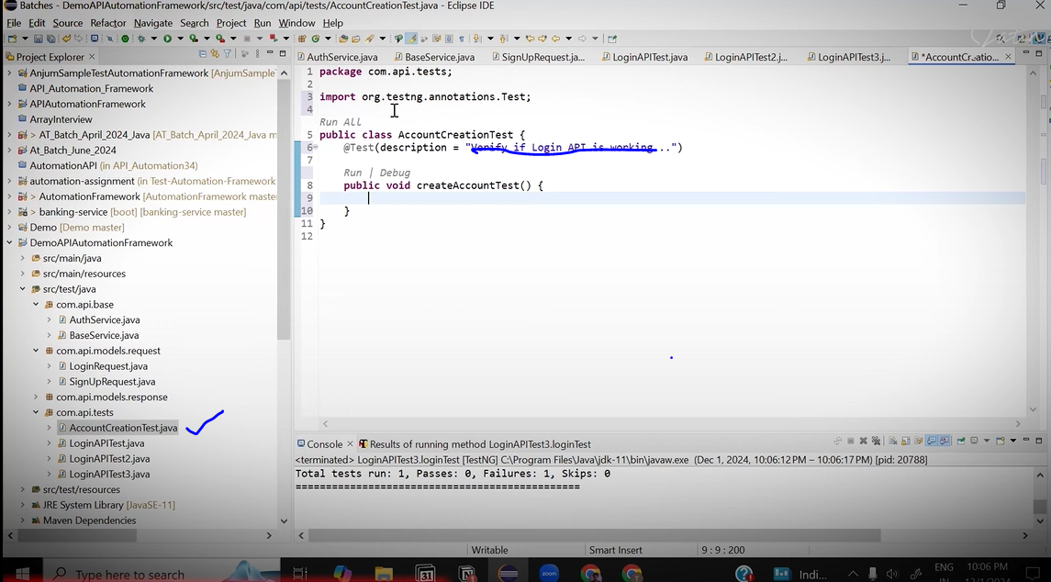

First of that one method in AuthService class for signup request.

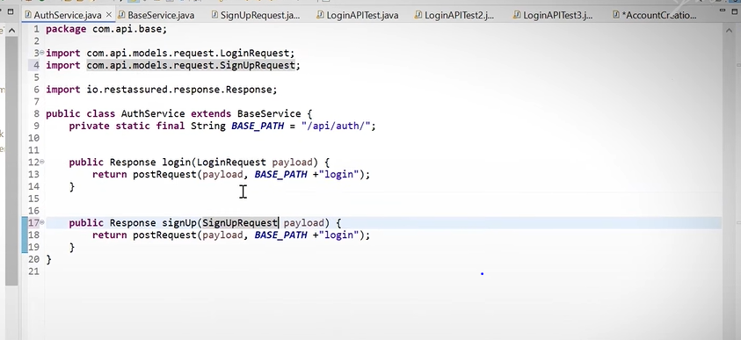

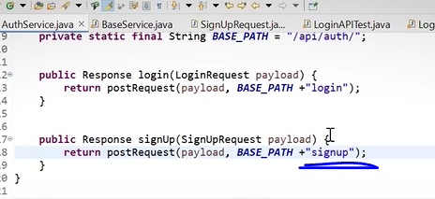

Now come in Account creation request

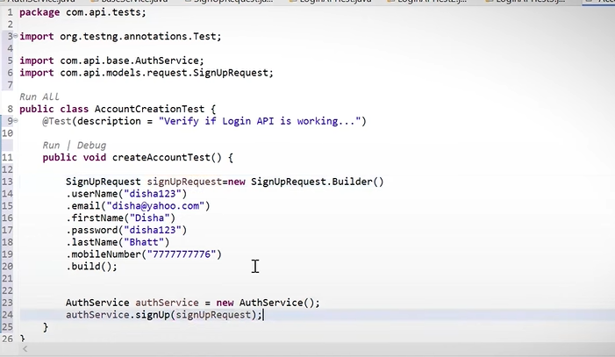

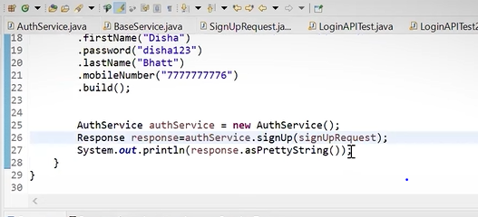

Now we using assert for verify the output.

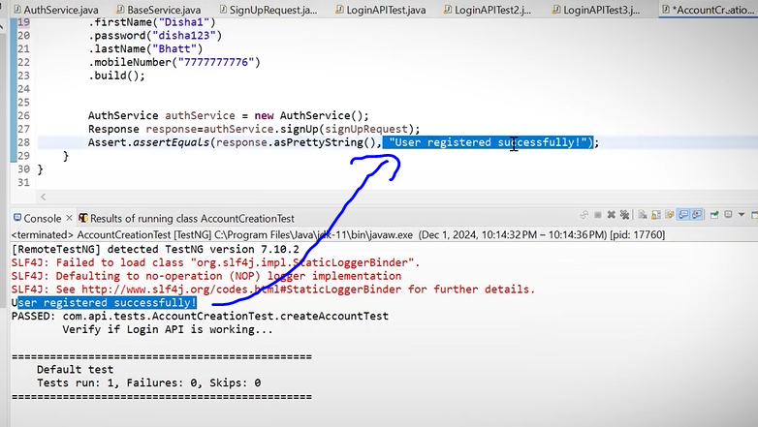

But consider here we are not creating response pojo here because in theresponse we are not getting result in Json . it coming only in just simple text.

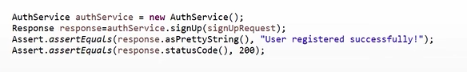

Now we are going to design a forgot password

Se here in the body there is only single value we have to enter so for that we can create POLO class aswell we directlt mentioned that in Authservice as below

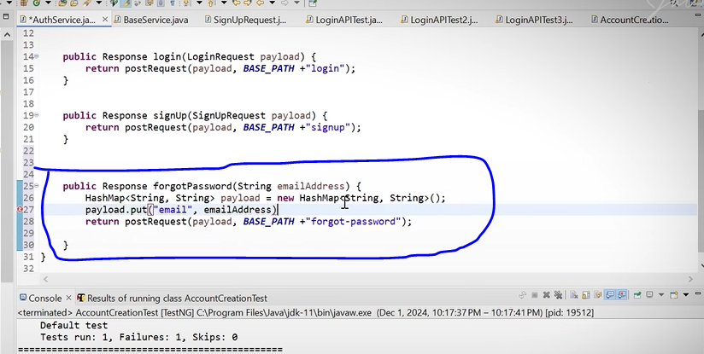

Then Create Forgot Passworrd text

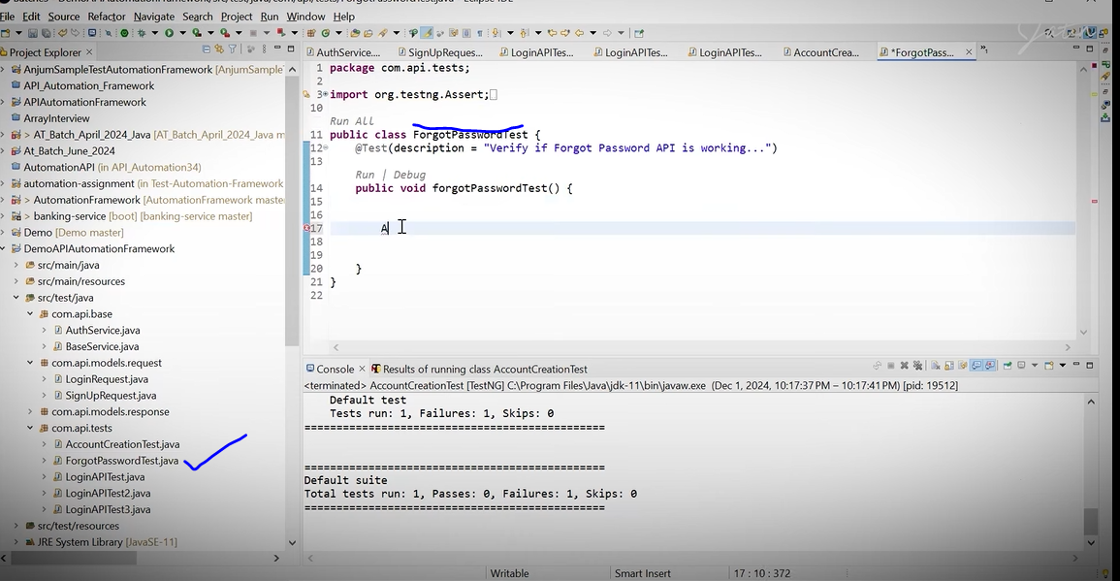

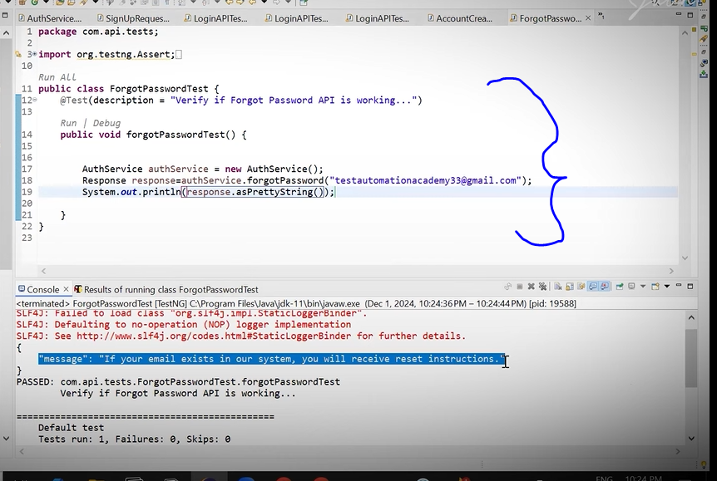

Now what are thing we test above it related to user creation, login, forgot password, its related to authentication level,

Now we are going to test user management level

So here first request use GET method, so go t the BaseService class.

One mor thing where is th get method there is no Payload(Body)

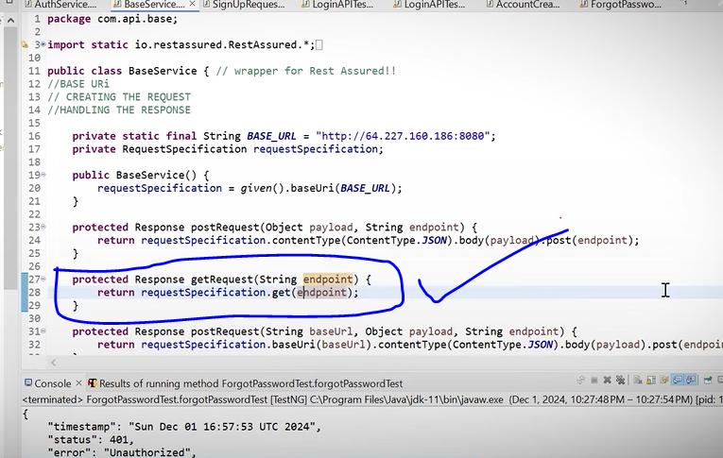

Now create a new class under for com.api.base for manage the userprofile related services

Classname – UserProfilemanagementservice

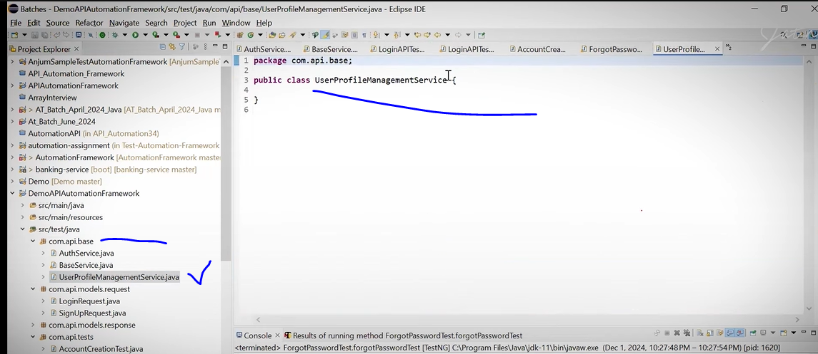

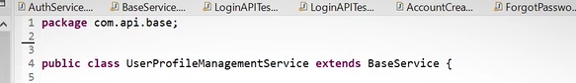

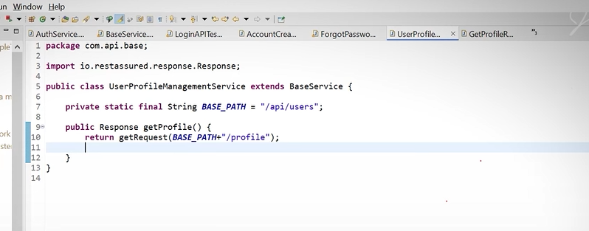

Now create GetProfilerequest class under com.api.test

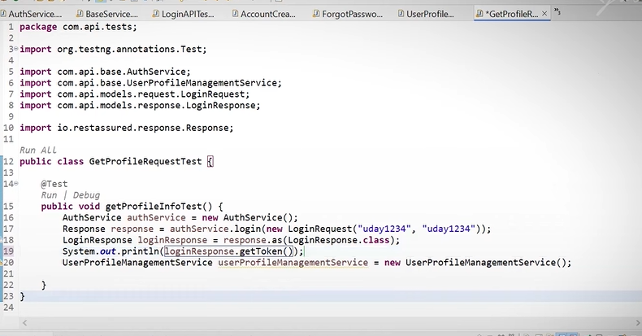

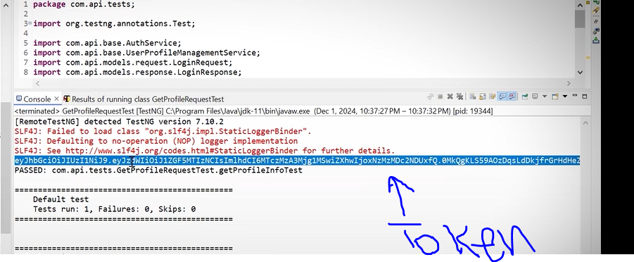

This token we need to user user related service

So we copy tht token and create a method in BaseService class

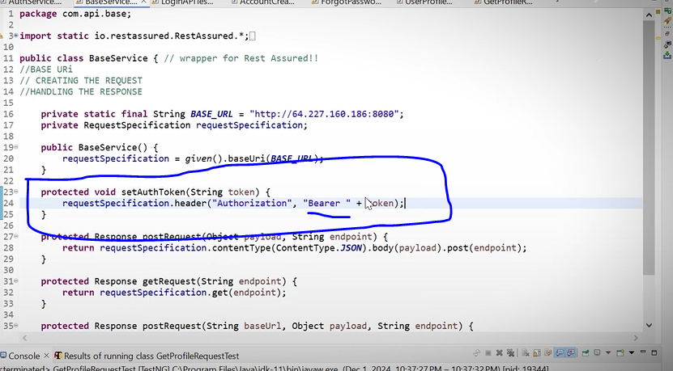

Now go to the go the UserProfileManagentService class

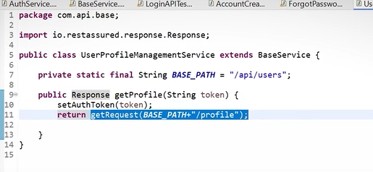

Now go to the Test class

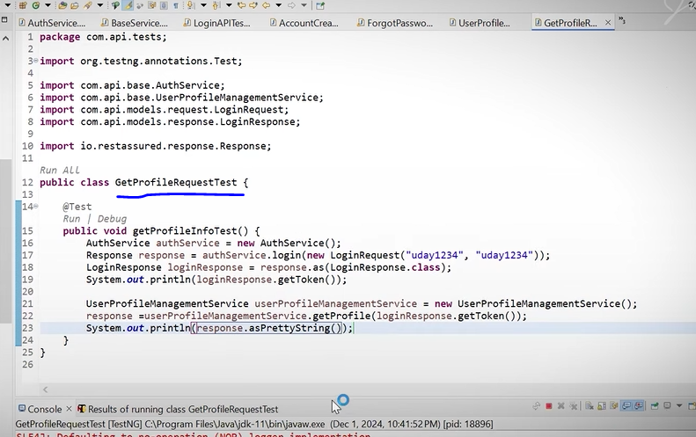

Response:-

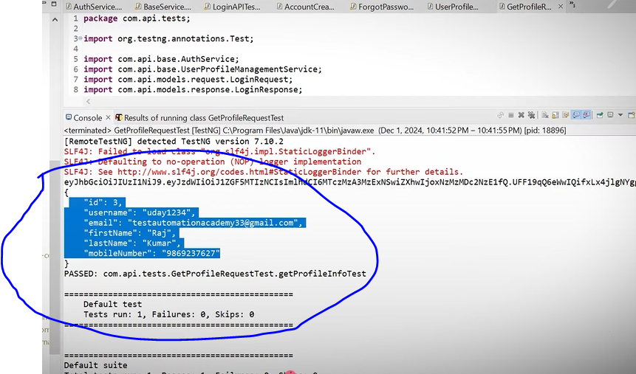

So here response is comin in Json format so we have to deserialized it

So go to com.api.models.request and crete a class – UserProfileresponse

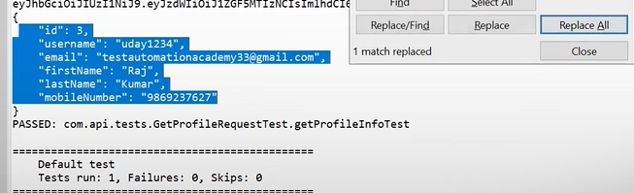

Copy that response and past in UserProfileResponse clas and remove “ : response valus just keep filed name

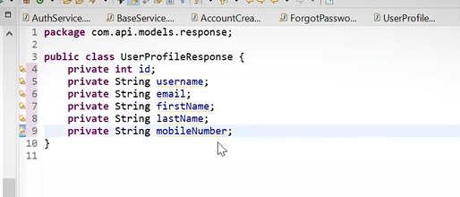

Then add constructor, getter setter and To String

Now create last builder for this (Inner class)

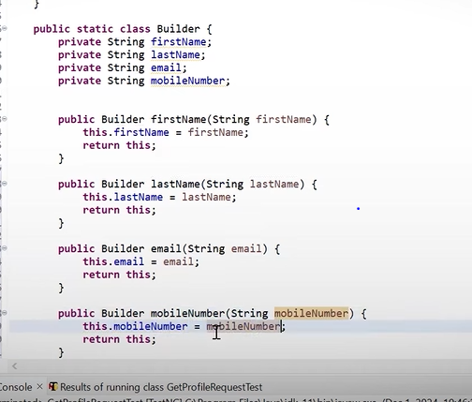

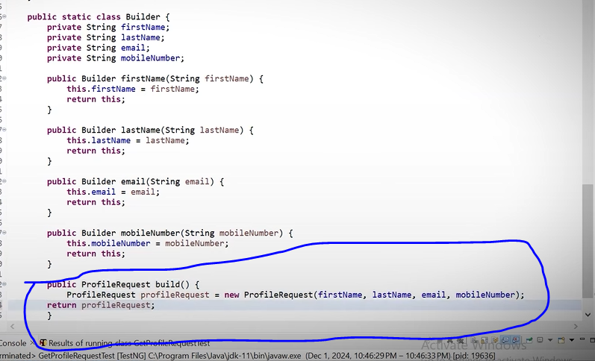

Create one test – UpdateProfileTest under thr trst package

Now in update profile we putting something so here we are using PUT method

So we have to do changes in create method in Base service classs for PUT method

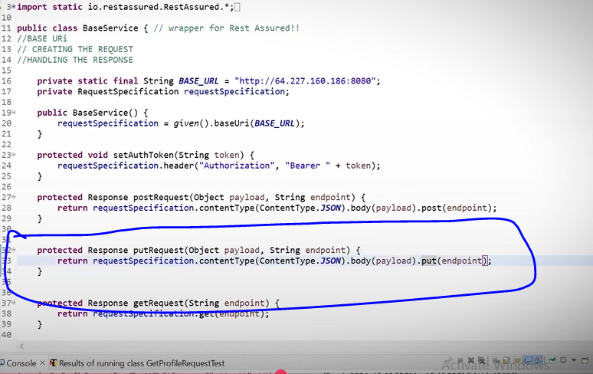

No go to userProfileManagementService class which is undder base package

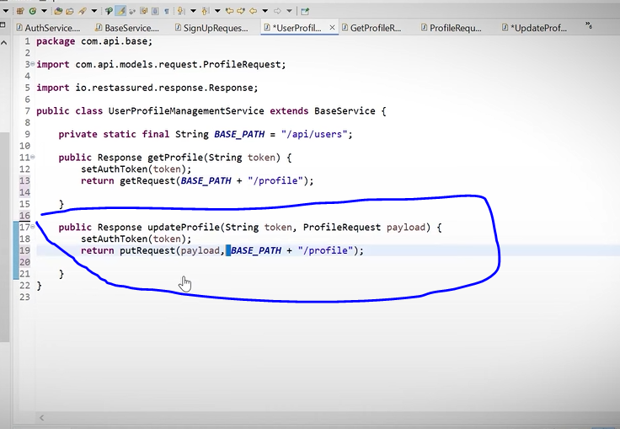

Then go back to test package and create updateprofile test

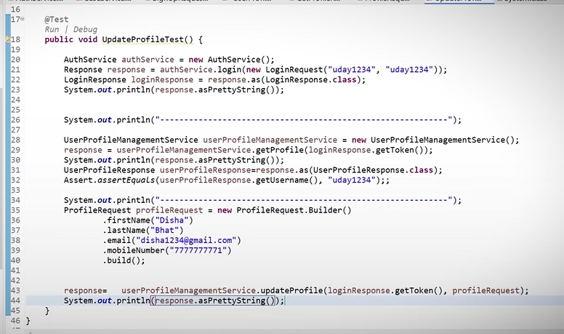

## 🧪 Overall Samajh Lo (Big Picture)

👉 Ye **ONE TestNG test** me **3 APIs ko chain** kar raha hai:

1️⃣ **Login API**  
2️⃣ **Get Profile API**  
3️⃣ **Update Profile API**

Aur har step me:

* token reuse ho raha hai
* response validate ho raha hai

## 🔰 Code Breakdown (Step by Step)

## 1️⃣ TestNG Test Method

@Test

public void UpdateProfileTest() {

✔ TestNG test method  
✔ Isi wajah se **Run | Debug green** dikh raha hai  
✔ TestNG isko test samajh raha hai

## 2️⃣ Login API Call (Authentication)

AuthService authService = new AuthService();

Response response = authService.login(

new LoginRequest("uday1234", "uday1234")

);

### Yahan kya ho raha hai?

* AuthService → **service class** (API calling logic)
* LoginRequest → **POJO** (username + password)
* login() → login API hit karta hai

📌 Output:

* Raw API response response me aa gaya

## 3️⃣ Login Response Parse Karna

LoginResponse loginResponse = response.as(LoginResponse.class);

System.out.println(response.asPrettyString());

✔ JSON response → LoginResponse POJO  
✔ Token yahin se milega  
✔ Pretty print sirf debugging ke liye

## 4️⃣ Divider Print (Debug clarity)

System.out.println("-------------------------------------------");

👉 Sirf console readable banane ke liye  
👉 Automation logic se koi lena dena nahi

## 5️⃣ Get Profile API Call (Using Token)

UserProfileManagementService userProfileManagementService =

new UserProfileManagementService();

response = userProfileManagementService.getProfile(

loginResponse.getToken()

);

### Important Concept 🔥

* **Token reuse ho raha hai**
* Login ke bina ye API kaam hi nahi karegi

📌 This is called:

**API Chaining**

## 6️⃣ Get Profile Response Validate Karna

System.out.println(response.asPrettyString());

UserProfileResponse userProfileResponse =

response.as(UserProfileResponse.class);

Assert.assertEquals(

userProfileResponse.getUsername(),

"uday1234"

);

✔ Response parse kiya  
✔ Username verify kiya  
✔ Assertion pass → profile correct user ka hai

## 7️⃣ Update Profile Request Build Karna (Builder Pattern)

ProfileRequest profileRequest = new ProfileRequest.Builder()

.firstName("Disha")

.lastName("Bhat")

.email("disha1234@gmail.com")

.mobileNumber("7777777771")

.build();

🔥 Ye **BEST PRACTICE** hai:

* Builder Pattern
* Clean
* Readable
* No messy setters

📌 Ye **request body** hai update API ke liye

## 8️⃣ Update Profile API Call

response = userProfileManagementService.updateProfile(

loginResponse.getToken(),

profileRequest

);

✔ Same token reuse  
✔ Profile update API hit  
✔ Response mil gaya

## 9️⃣ Final Response Print

System.out.println(response.asPrettyString());

✔ Update ka final output  
✔ Debug + confirmation

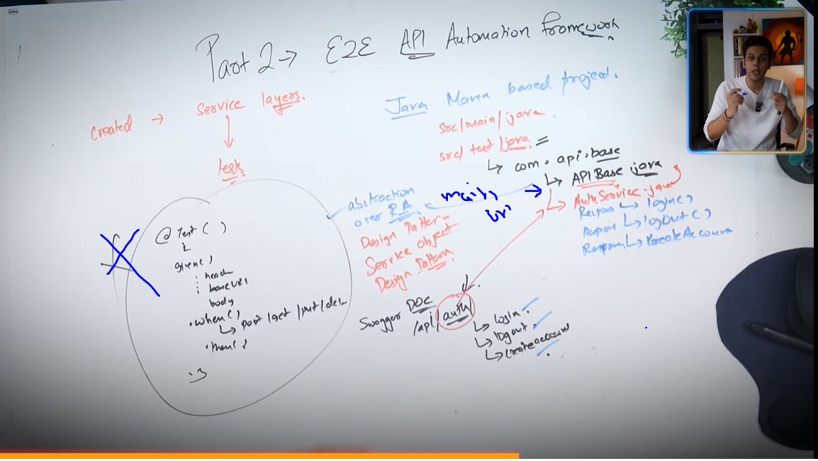

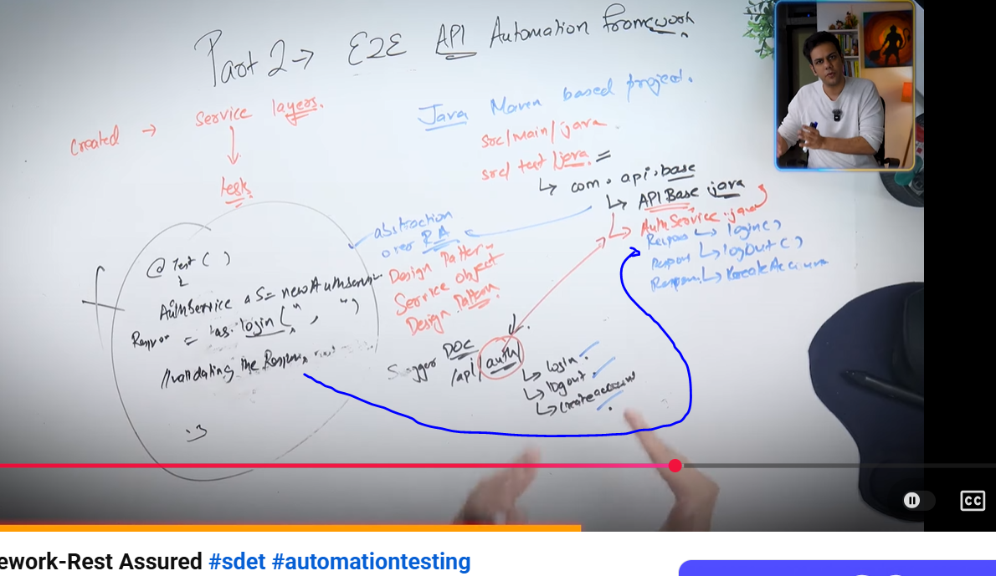

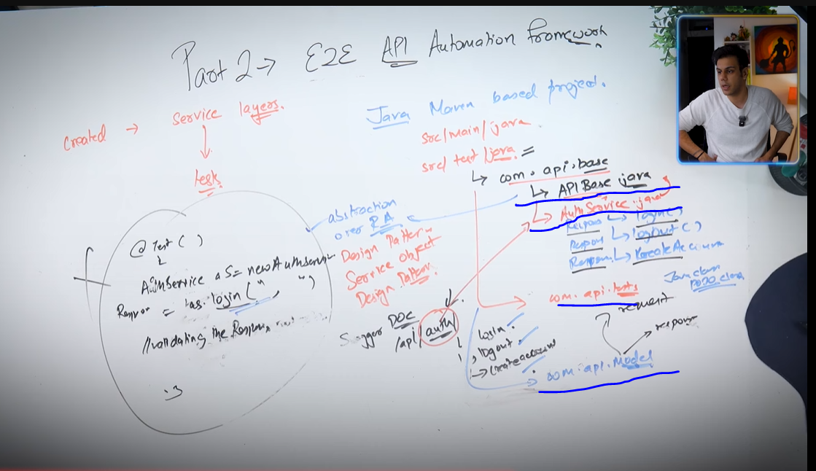

Now Part2 is start from here

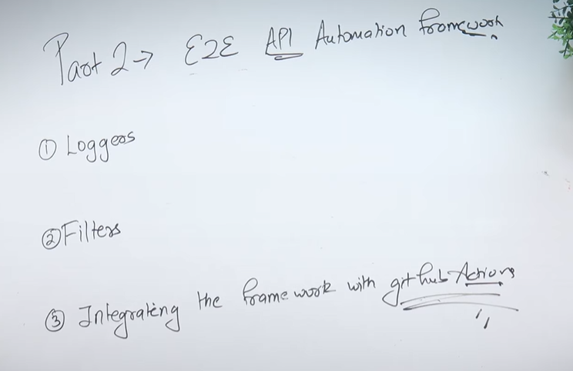

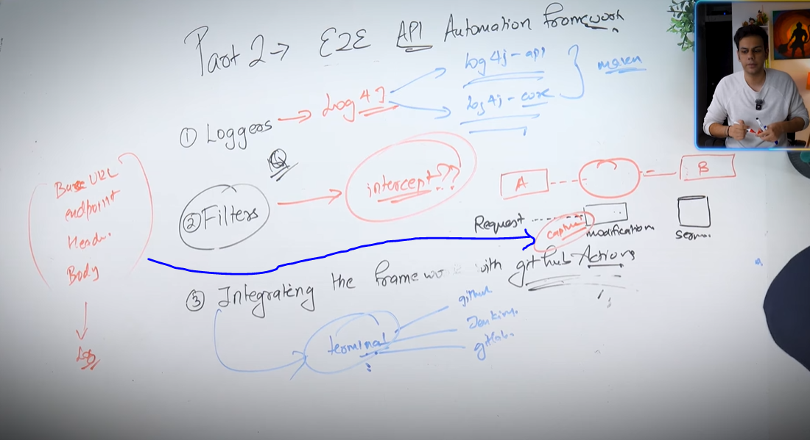

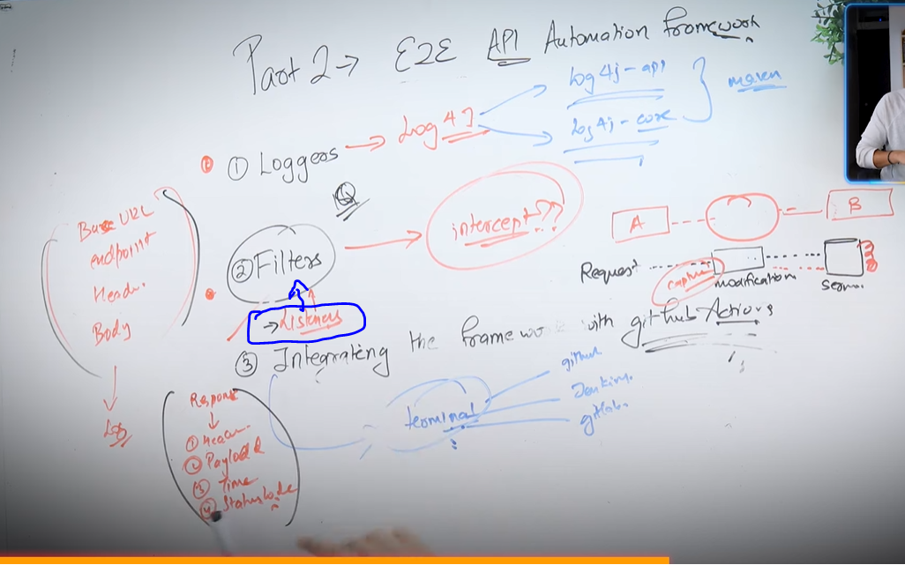

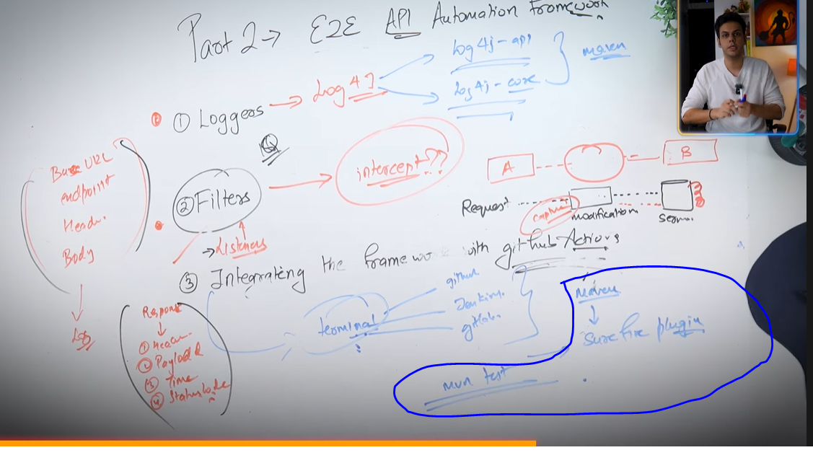

Interview question :- what are the enhancements you are did in your framework?

So in previous we create below 4 packages.

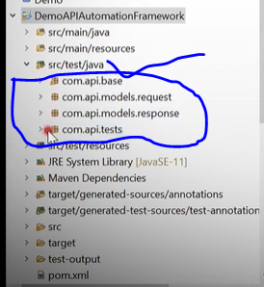

Interview Question :- What are the different design patterns you aware ?

Now we need to add log4j-api & log4j-core dependency.

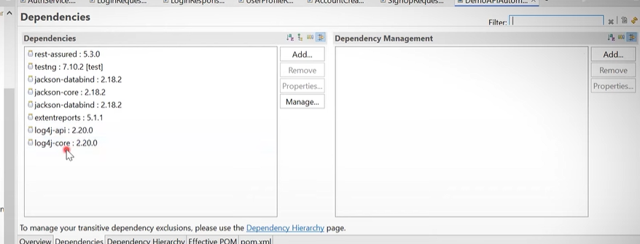

That dependencies available on - <https://tech-with-jatin.notion.site/E2E-Automation-Framework-Creation-1526d427c22780328b8fff211ee050b7#1526d427c22781e887a5f14c64b15cd7>.

Create one file under ‘src/test/recources’. File name is log4j2.xml

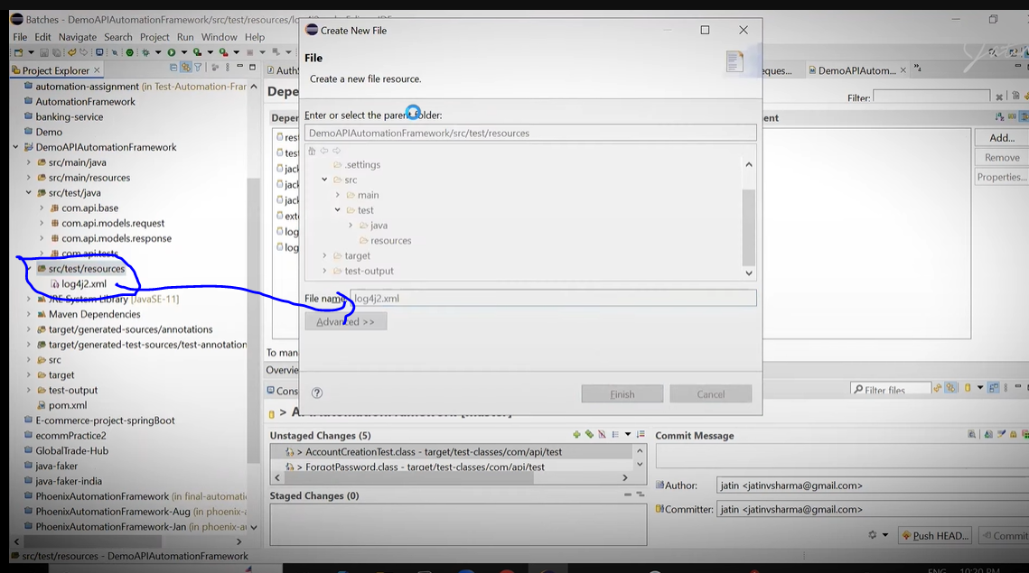

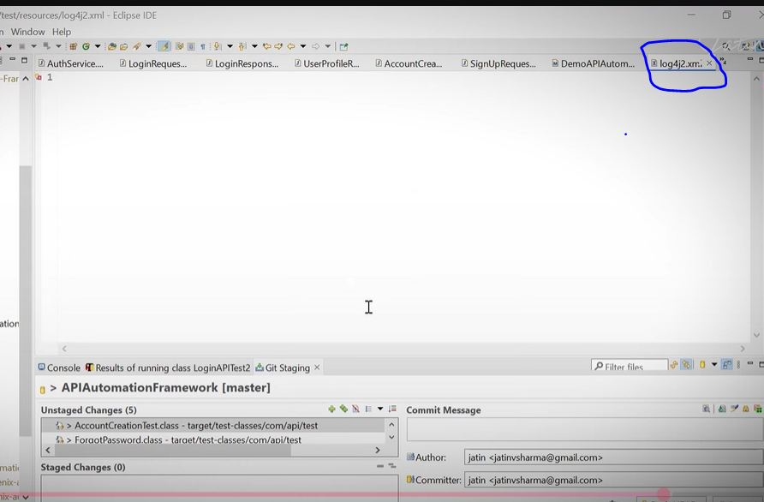

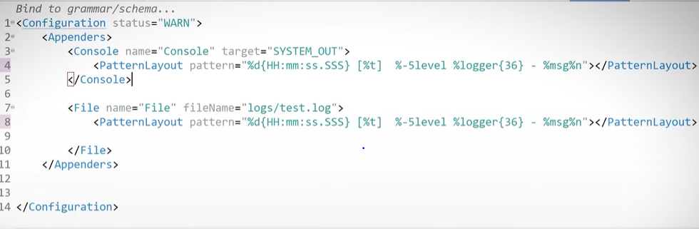

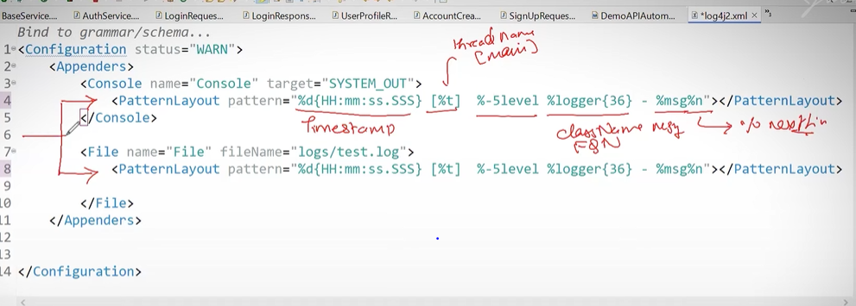

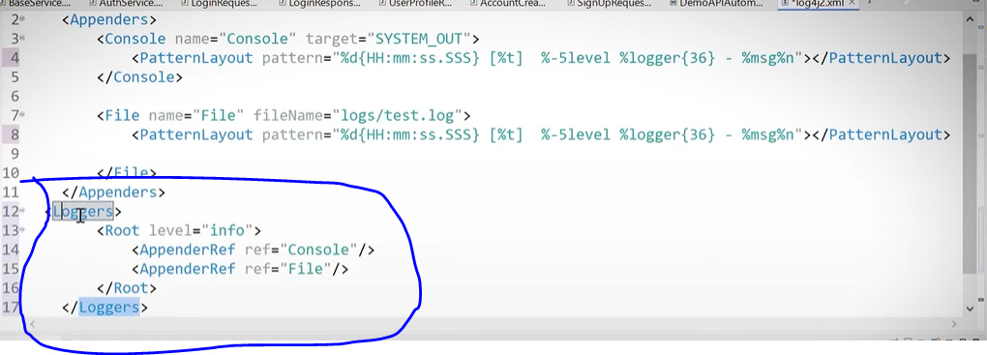

Now we are going to create listeners

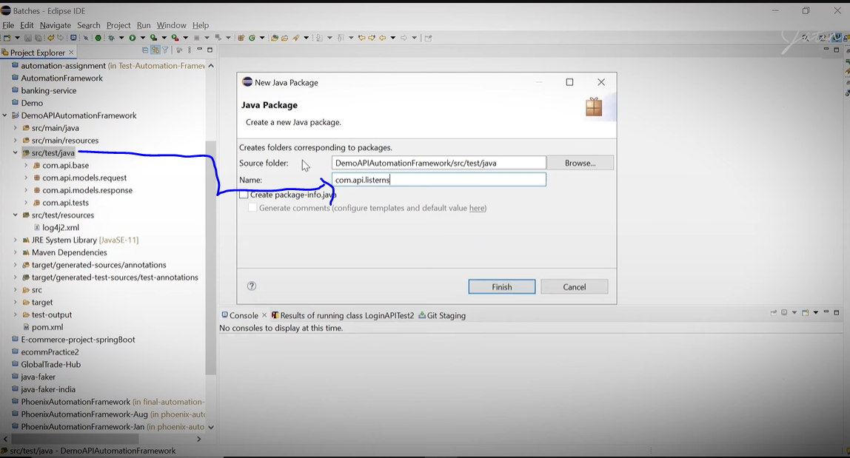

Now create a class under Listeren package – TestListner

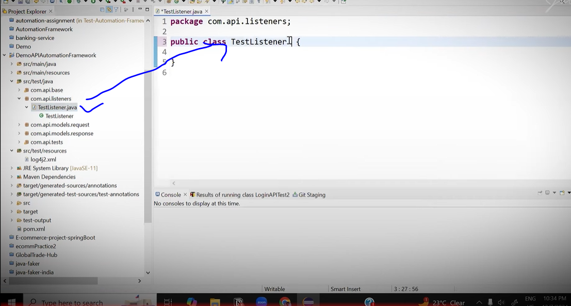

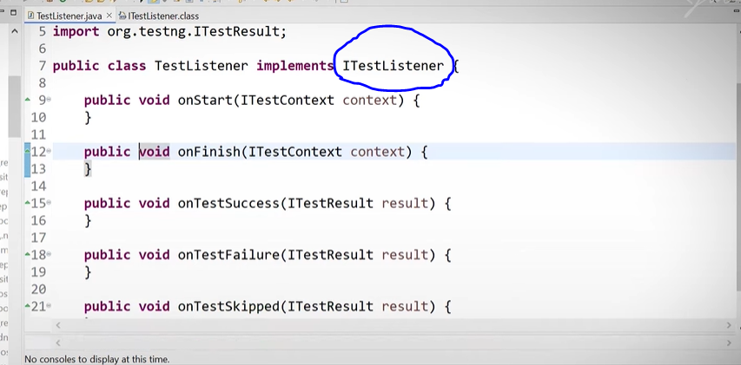

ITestListner ek inbuilt class bnt hai uspe click kare to uske undar method copy past idar karana hai aur unko public karana hai

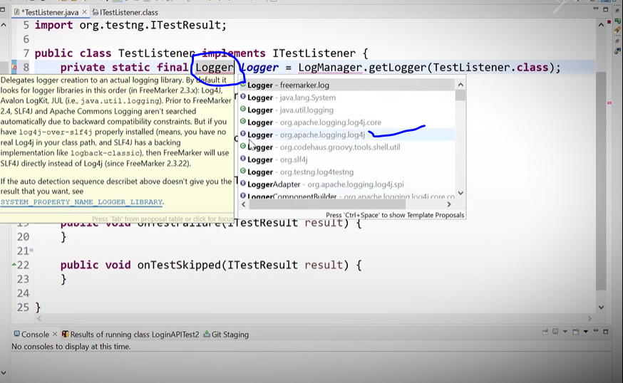

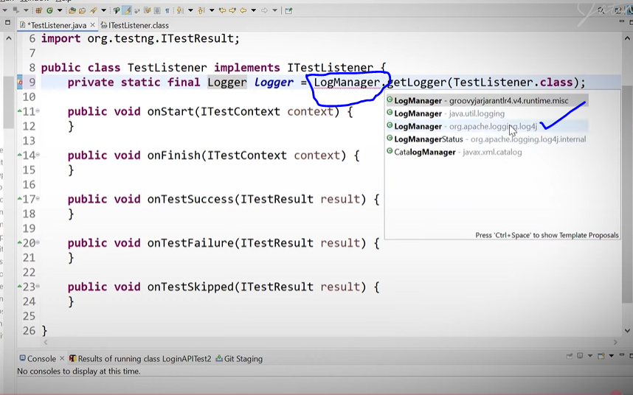

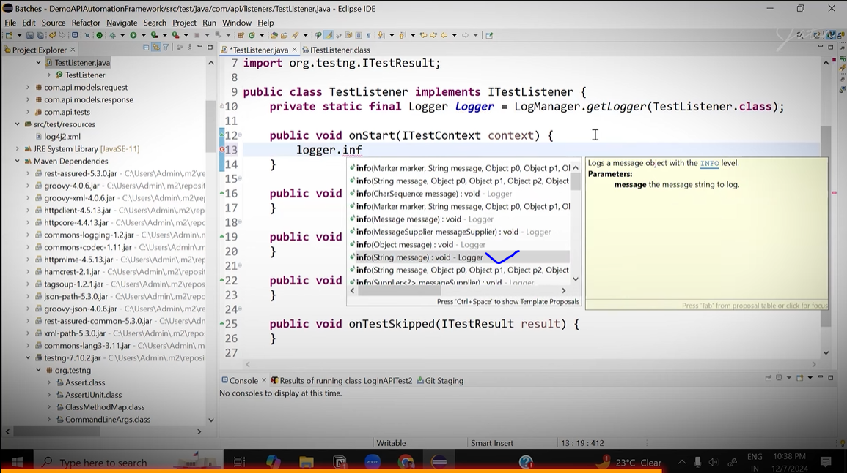

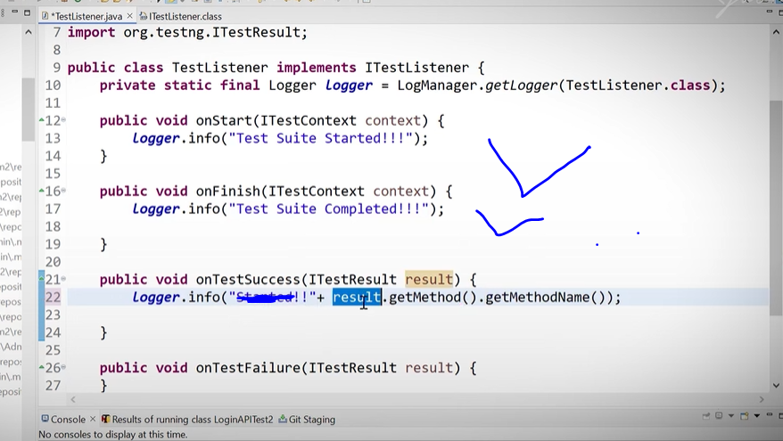

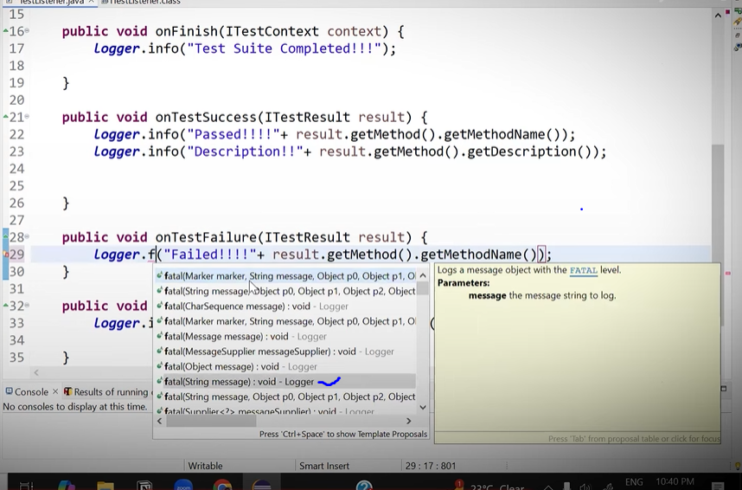

New method added which is missed

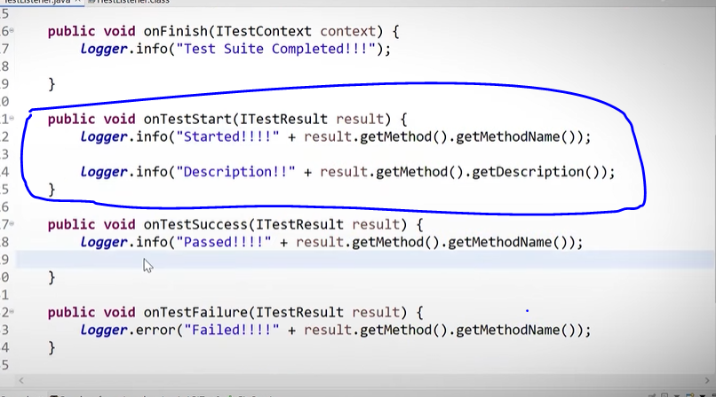

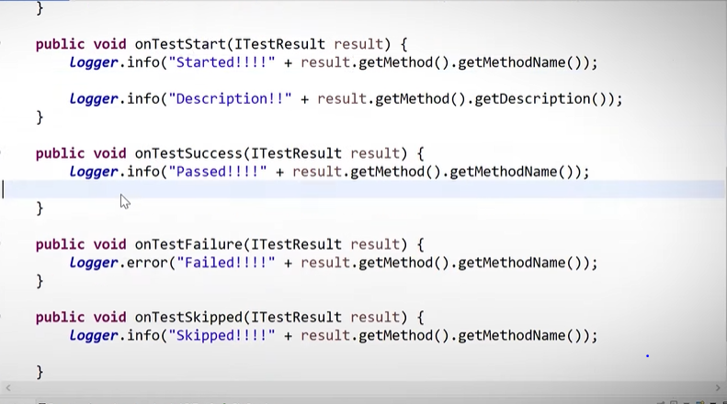

Now goto your login test class and add listener

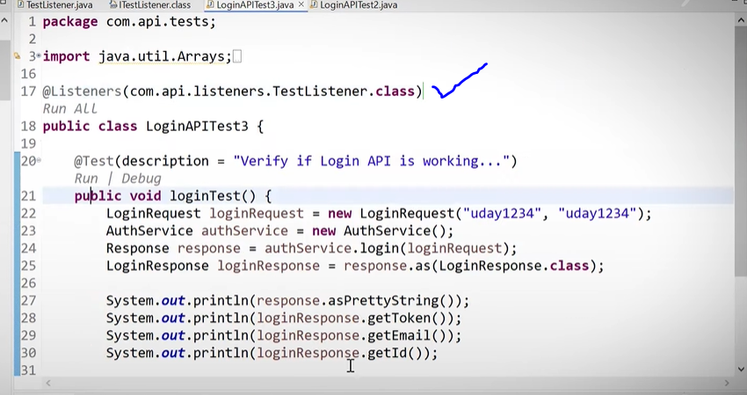

Now we are goint to create 1 package name called filters

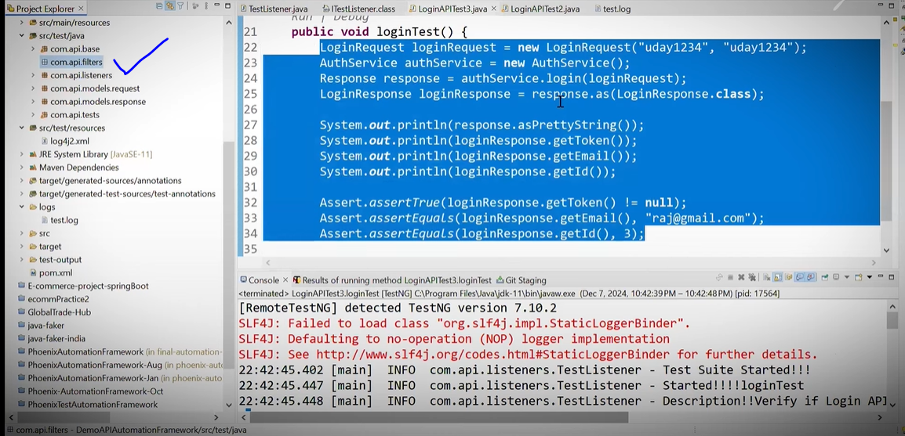

Int qn :-What are the filters? -> Filters help you o intercept the request.

Int qn :- What is the meaning of interception ? -> Interception means , before I make the request capture the information ma be for login purpose, may fore reporting purpose I need intercepted it hence the filteres come in the picture.

Now create a class ‘LoggingFilter’ inside filter package

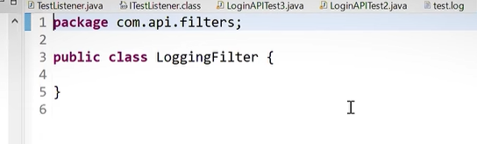

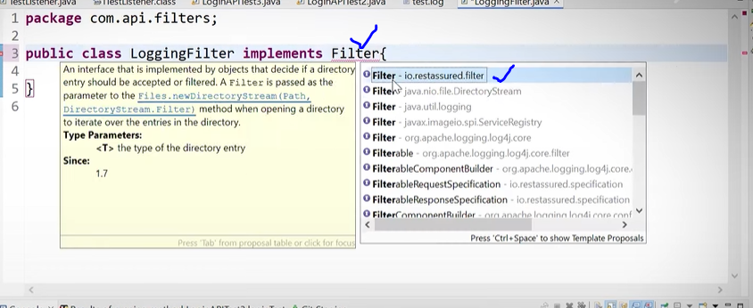

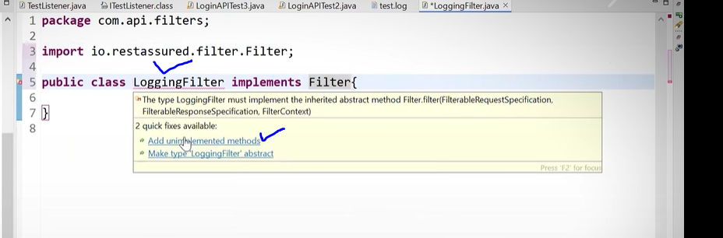

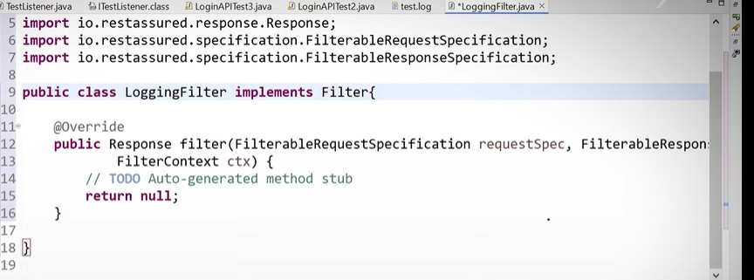

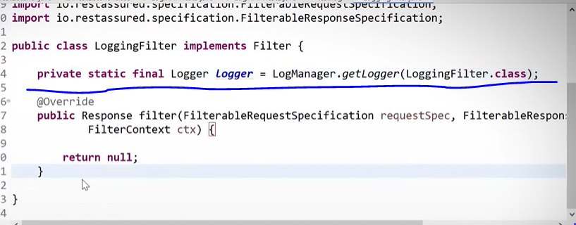

Logger take from apache log4j.

Now we are goint to create 2 methods

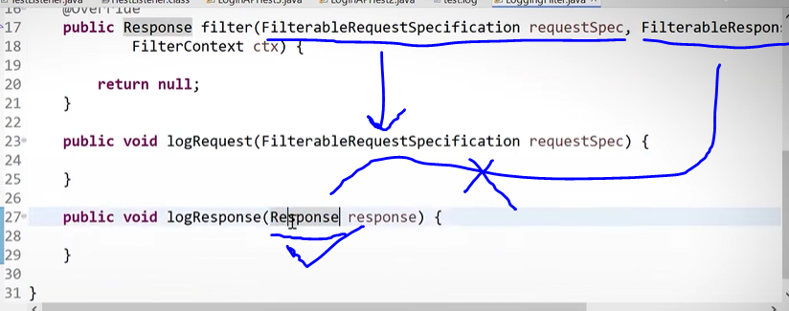

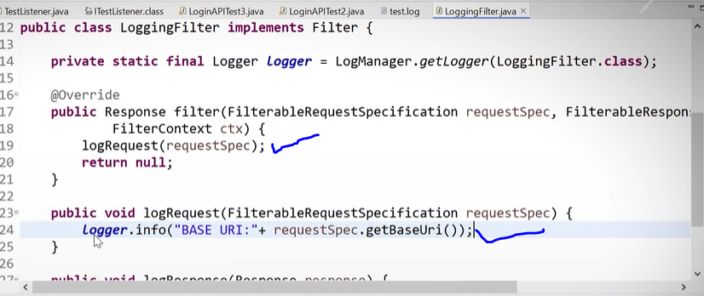

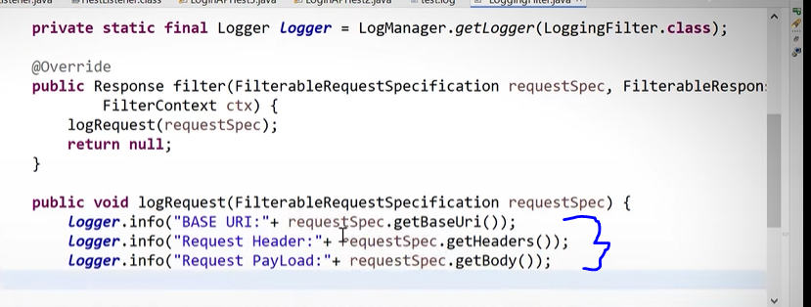

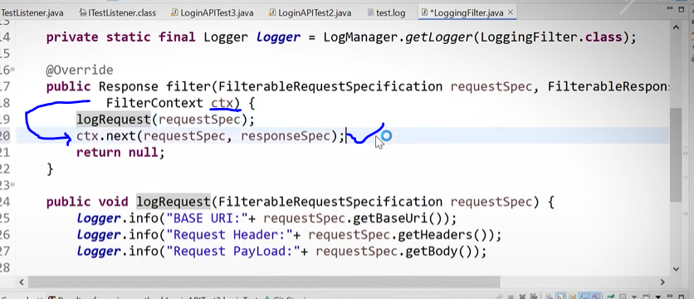

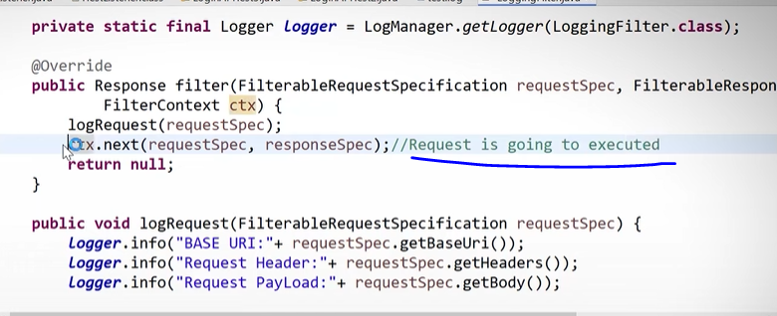

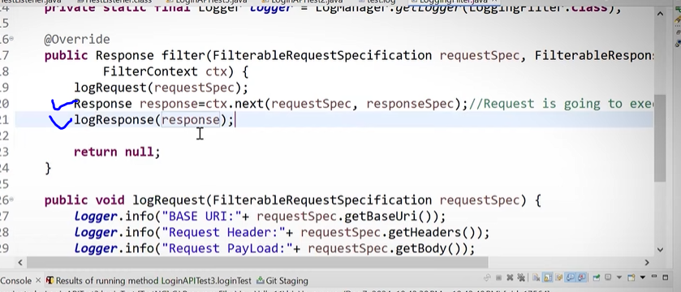

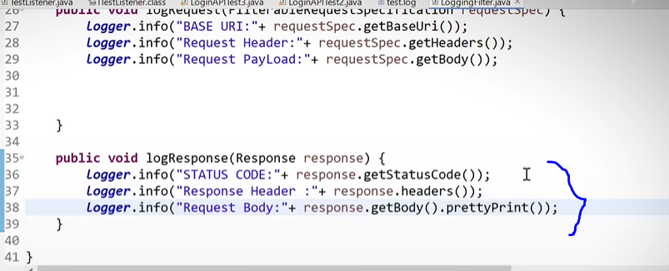

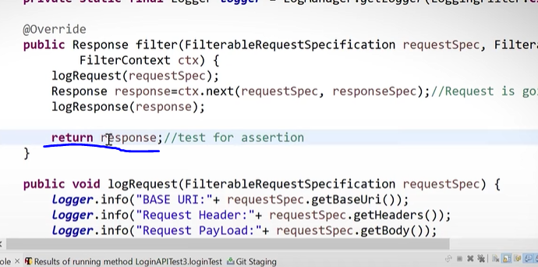

Final its look like this below

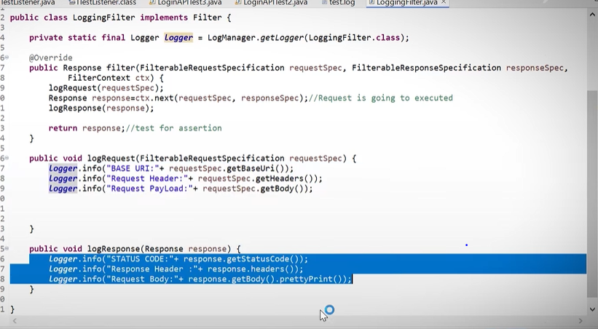

Nowgo to base package and open baseservice class

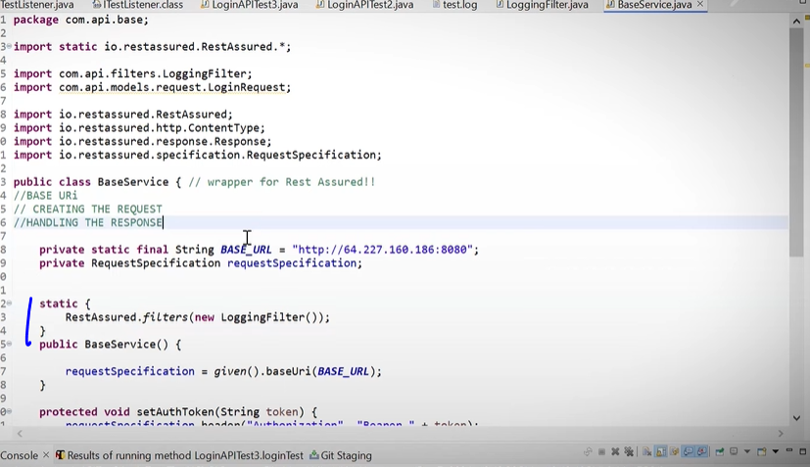

Now run the class and check the result, listeners creating the new folder with log file.

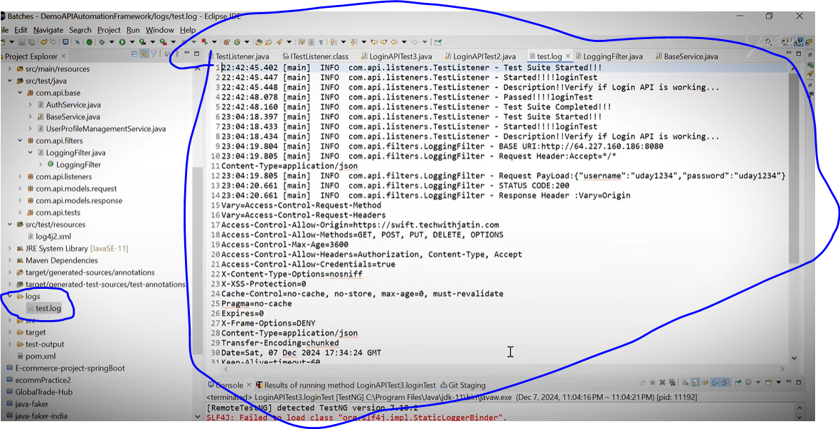

Now I want to execute this from terminal. Its help to run on Jenkins

So we need toad plugging (showfire) in pom.xml.

But before that we have to change something

Find the failed.xml file.

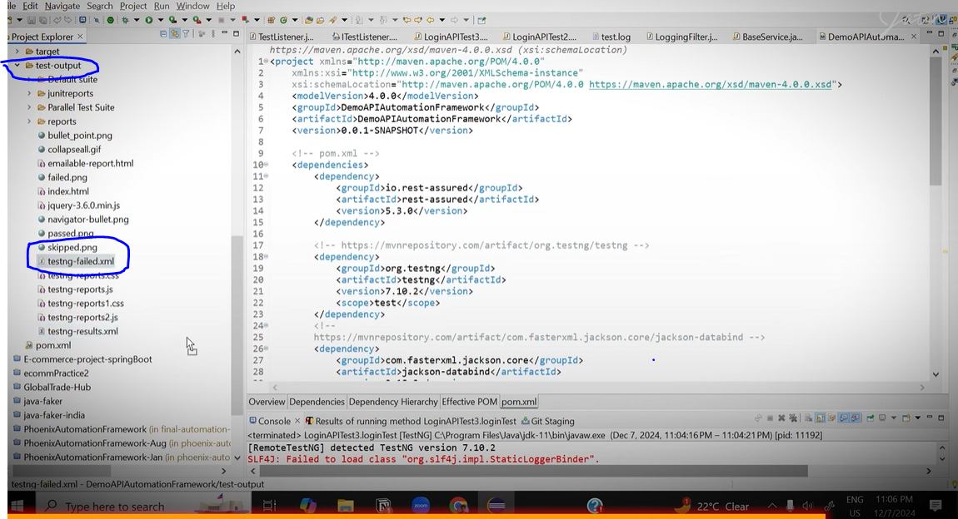

And put it outside as below.

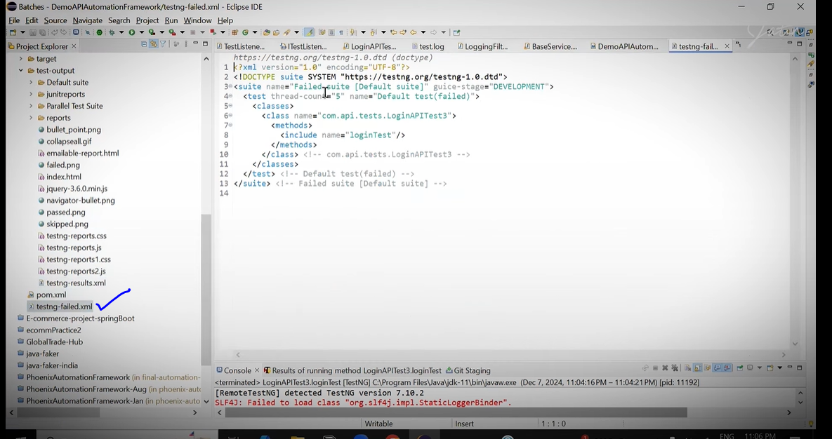

Now make a changes in failed.xml file, we need to going add classes in this file

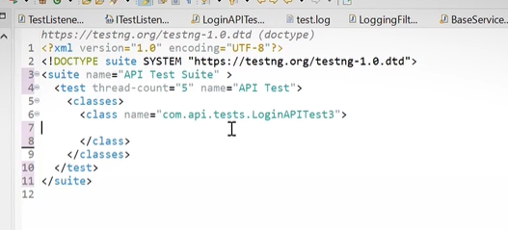

Rename this file as ‘Suit.xml’

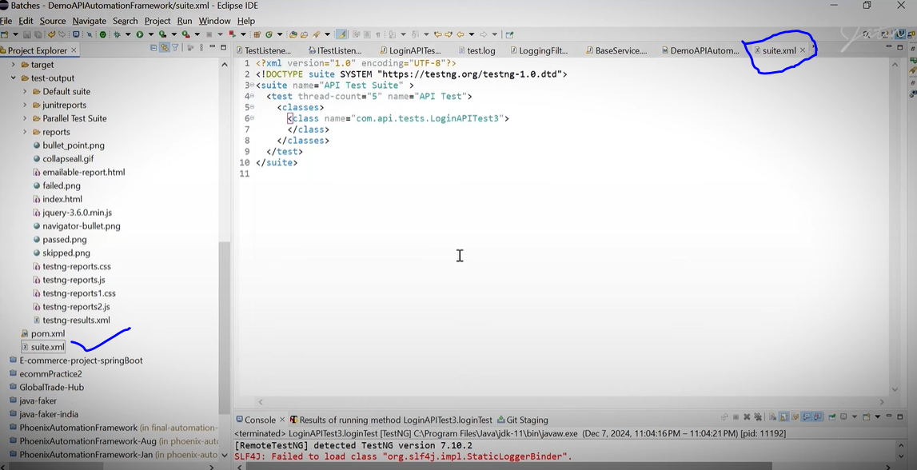

Now go to pom.xml file and introducing new plugins

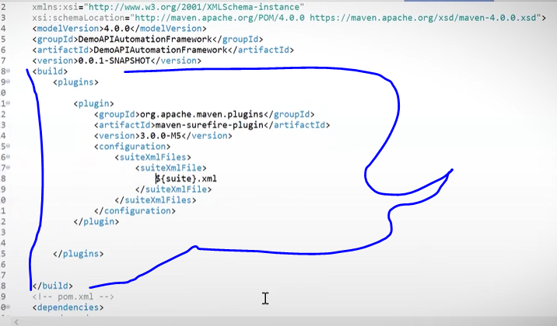

<build>

<plugins>

<plugin>

<groupId>org.apache.maven.plugins</groupId>

<artifactId>maven-surefire-plugin</artifactId>

<version>3.0.0-M5</version>

<configuration>

<suiteXmlFiles>

<suiteXmlFile>

src/test/resources/suites/${suite}.xml

</suiteXmlFile>

</suiteXmlFiles>

</configuration>

</plugin>

</plugins>

</build>

Also we need to add compiler version (java version) in pom .xml

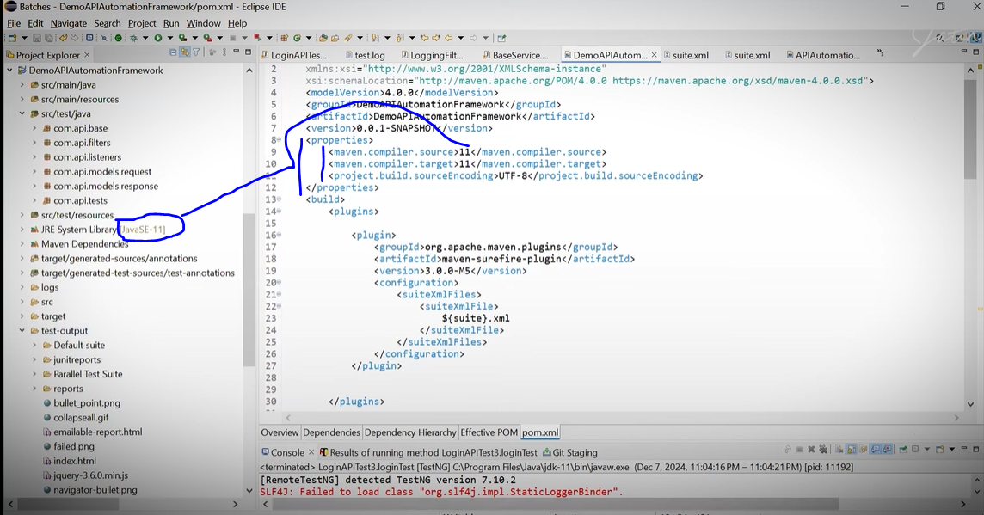

Now the project is ready,

So go on your project name right click and

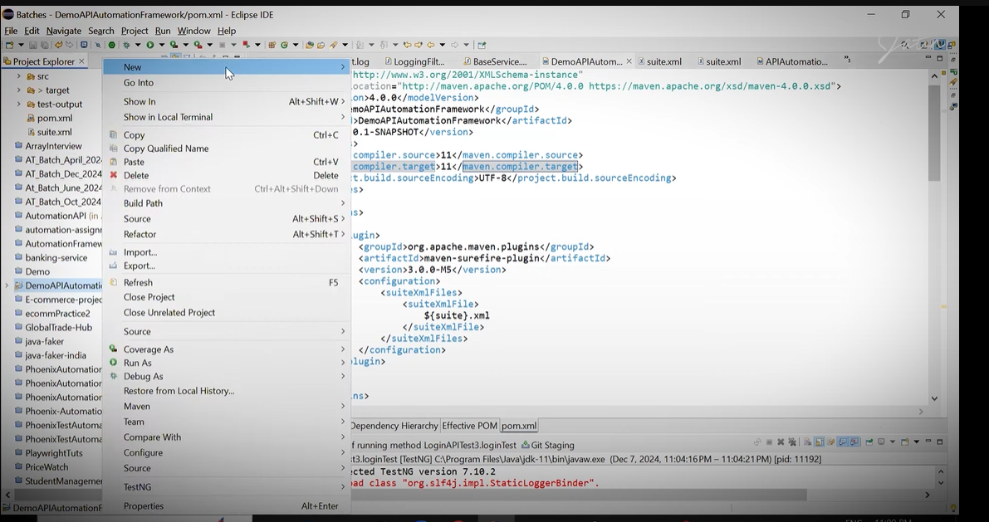

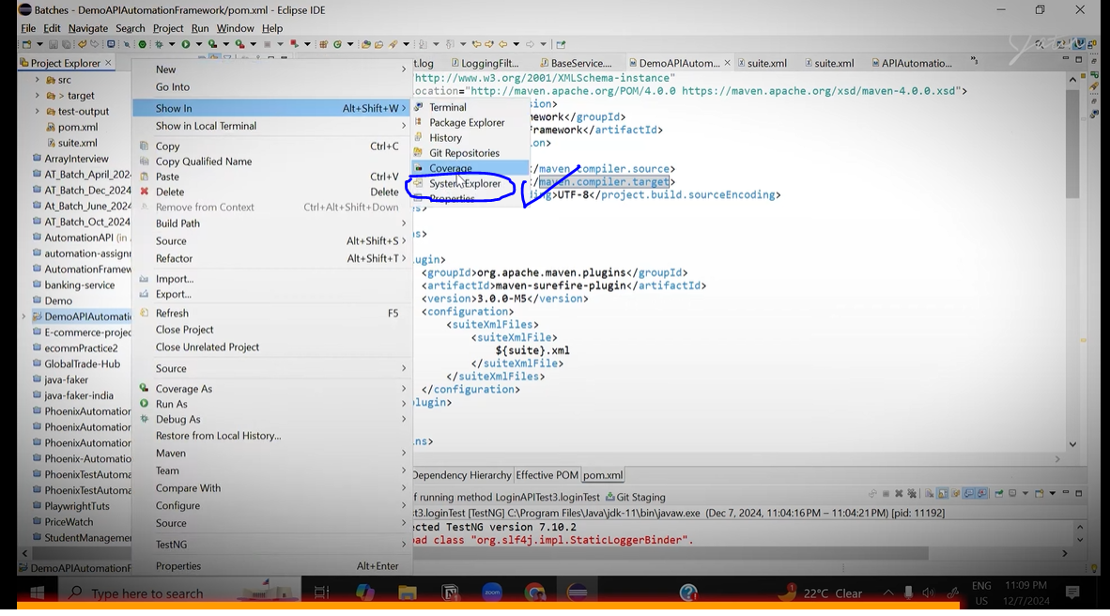

After that you will navigate on folder and open there gitbash

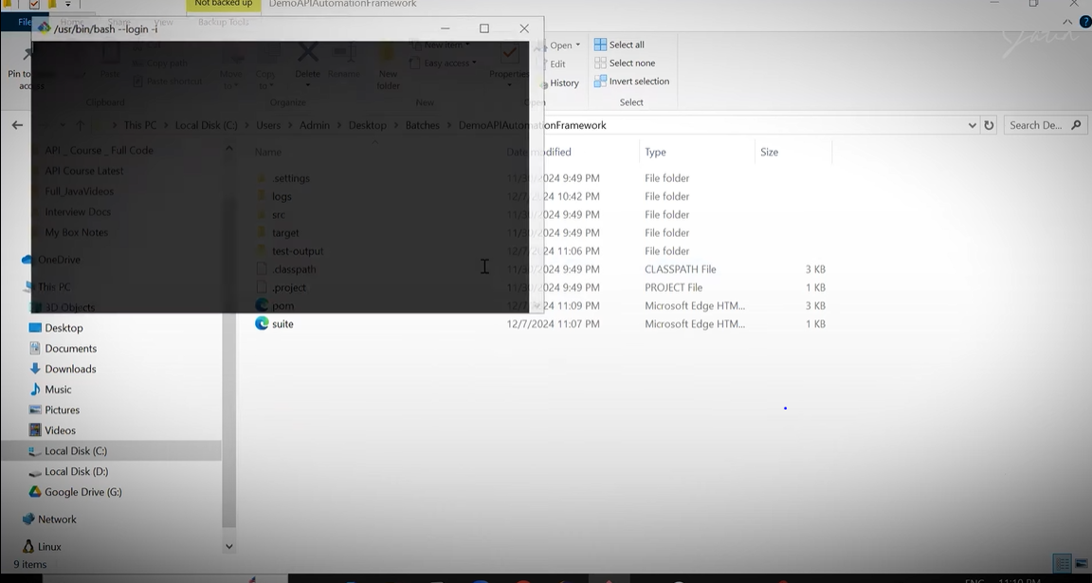

Enter command

mvn clean test –Dsuite=suite (Then press enter)

mvn clean test -Dsuite=src/test/resources/suites/Postlogin.xml

(here issuit is my that Suite.xml file name)

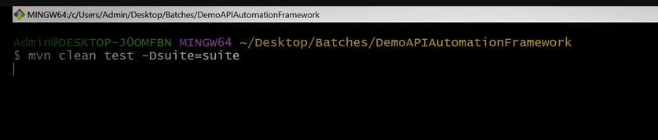

Now the time is push to project on gitub

Right click on project

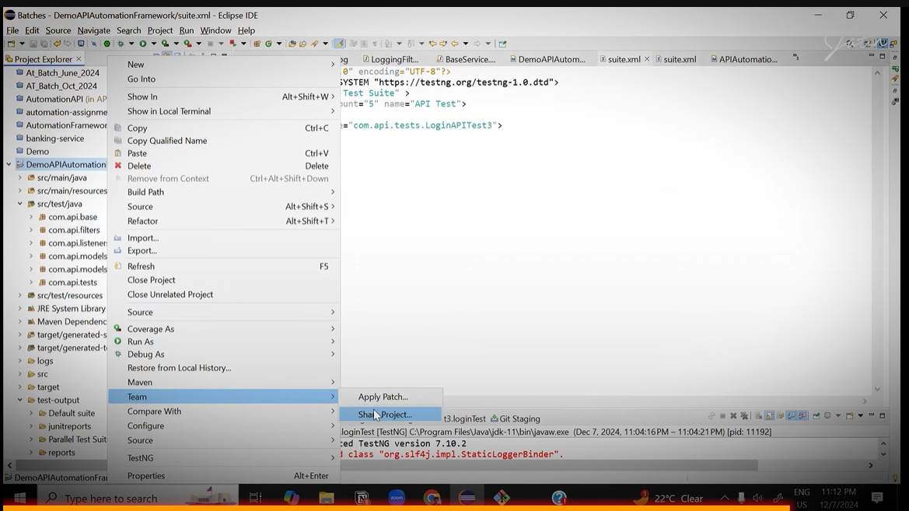

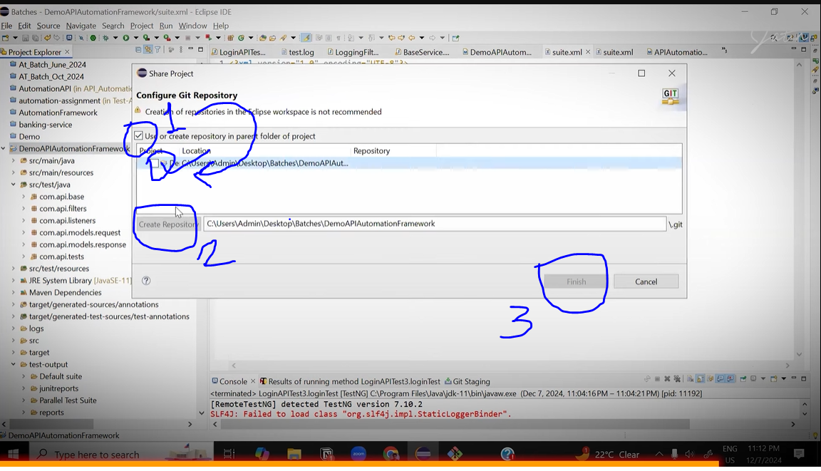

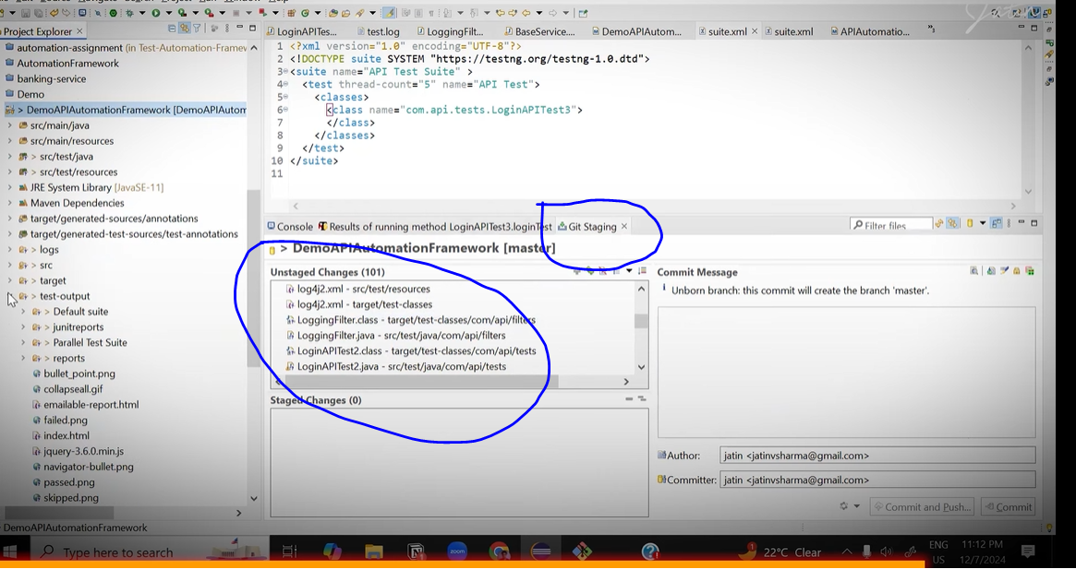

Some of things not mandatory here

What things are not mandatory/ should not to commit ? -> Anything that autogenerated.

So wh have to ignore that things.

Test-output folder

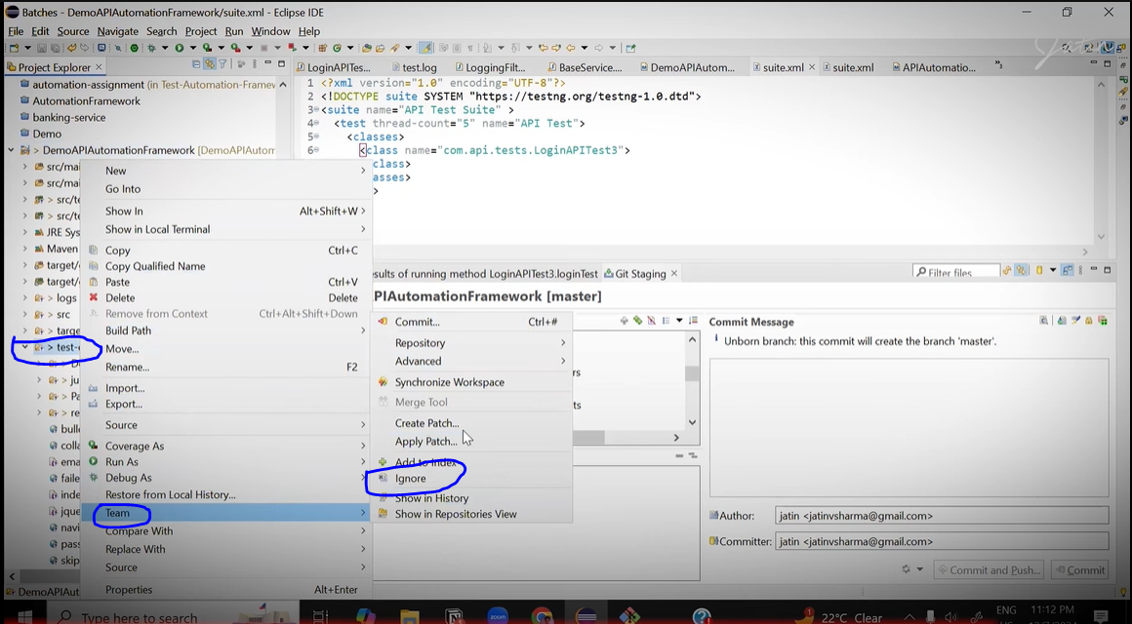

Next – target folder we have to ignore

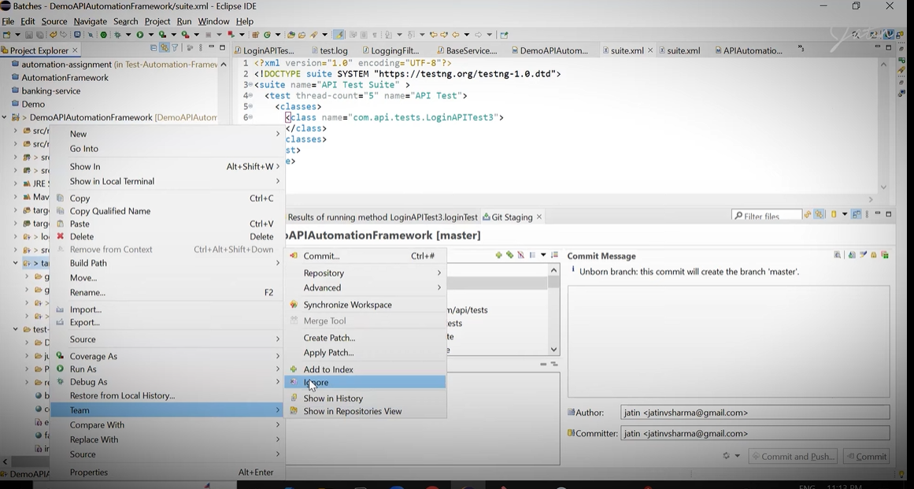

Next – logs folder we have to ignore

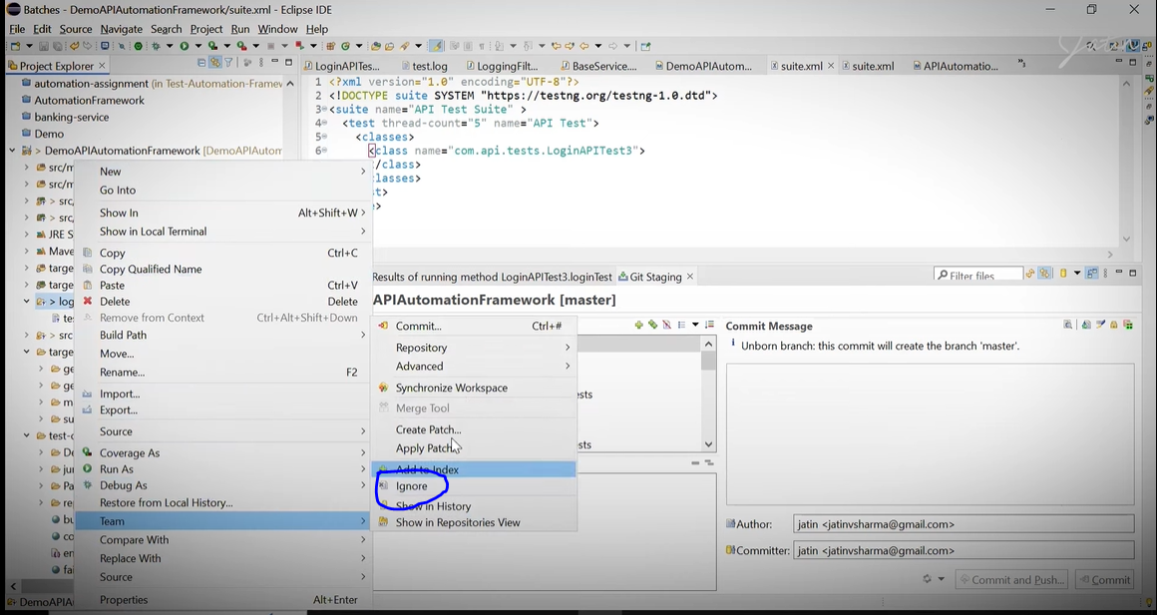

Then click on circe marked button

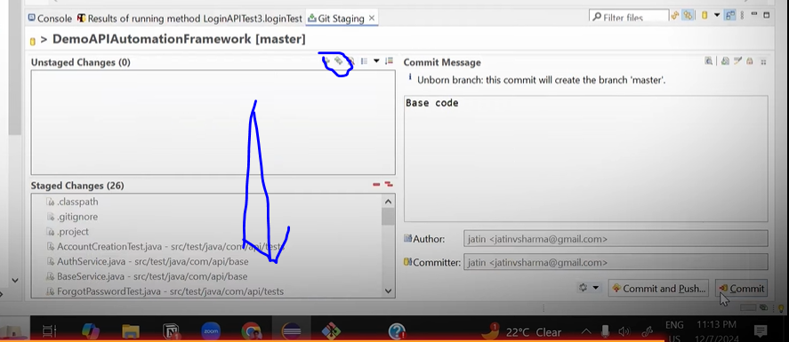

Enter commit text – Base Code

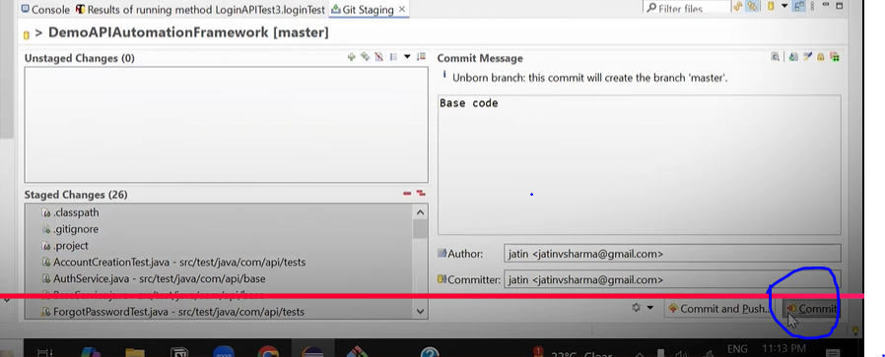

And click on commit

Now go to the github

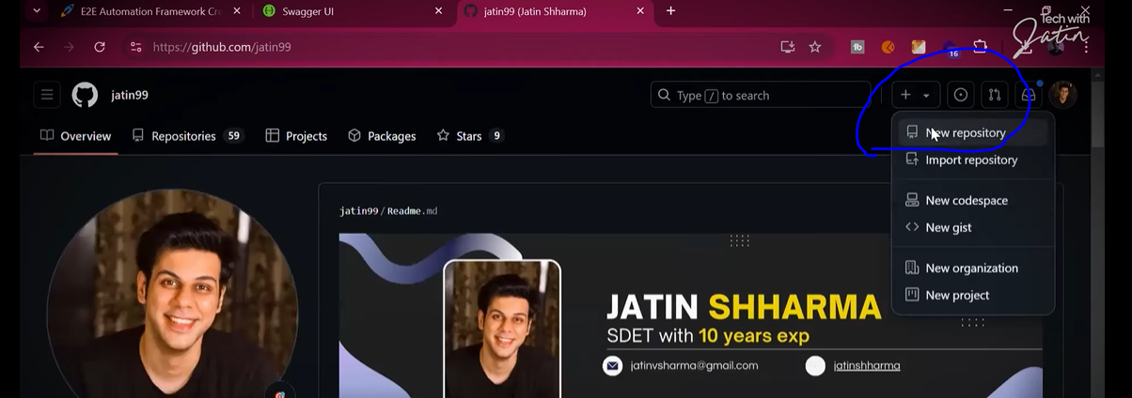

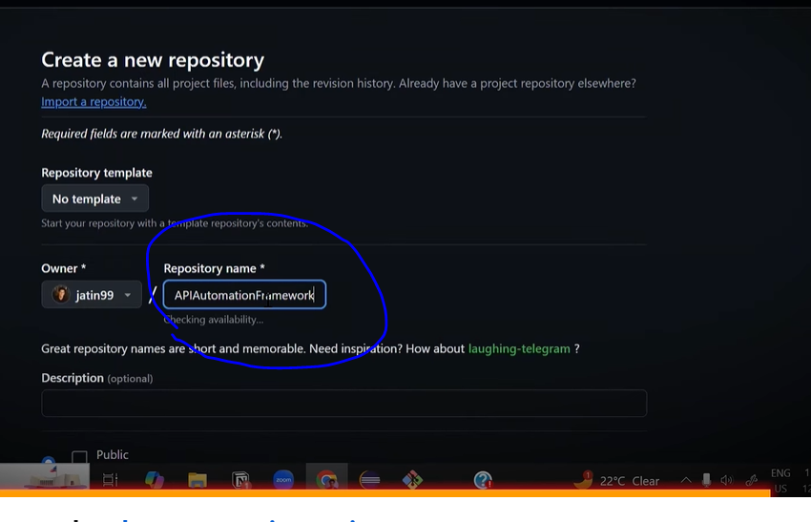

Give the name demo APIautomationframework

Copy that name and past in the – Description

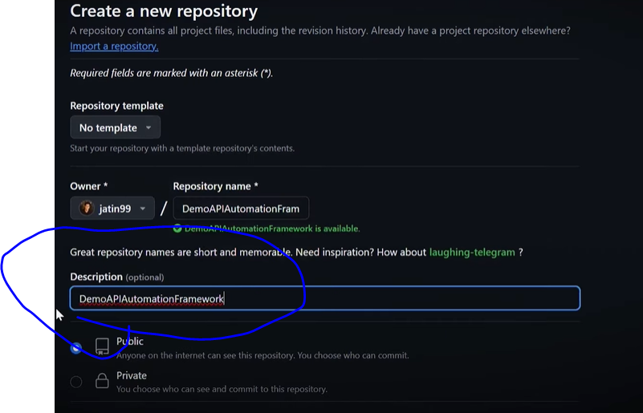

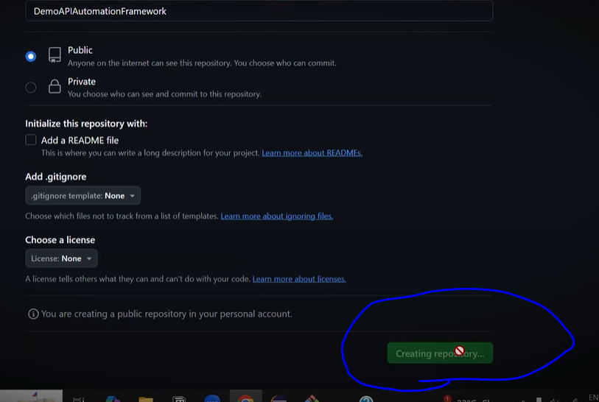

Copy the repote repository

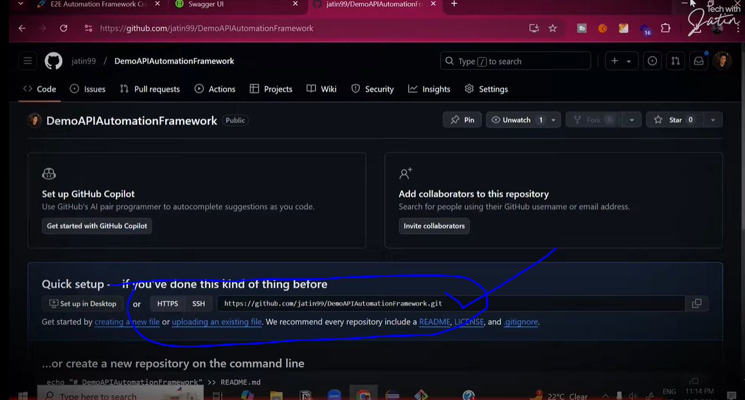

Go to eclipse and push it as below

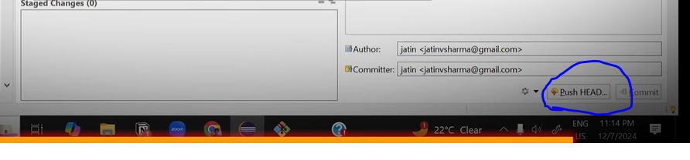

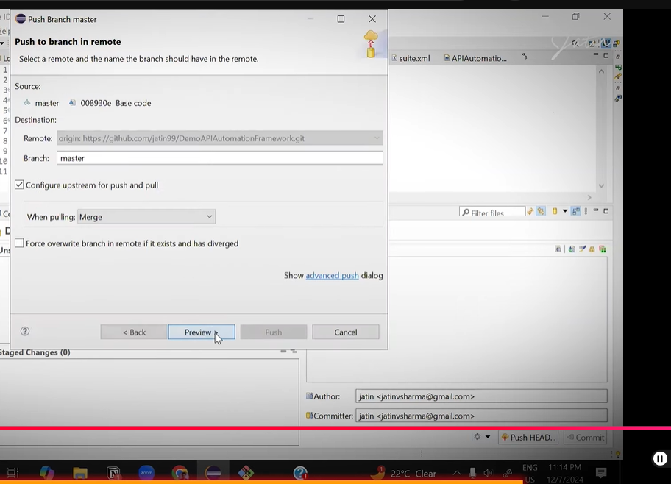

Click on preview thn push

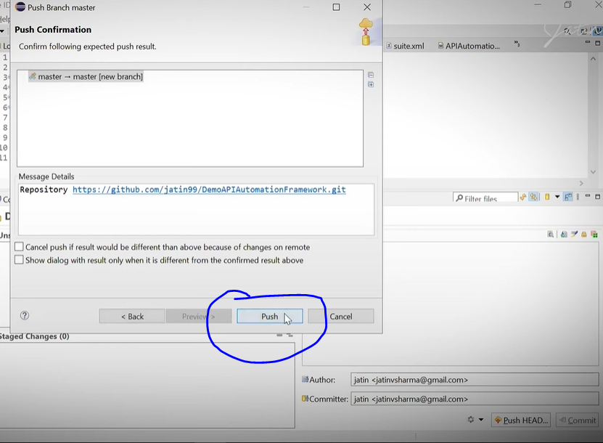

Go back to the github and refresh it.

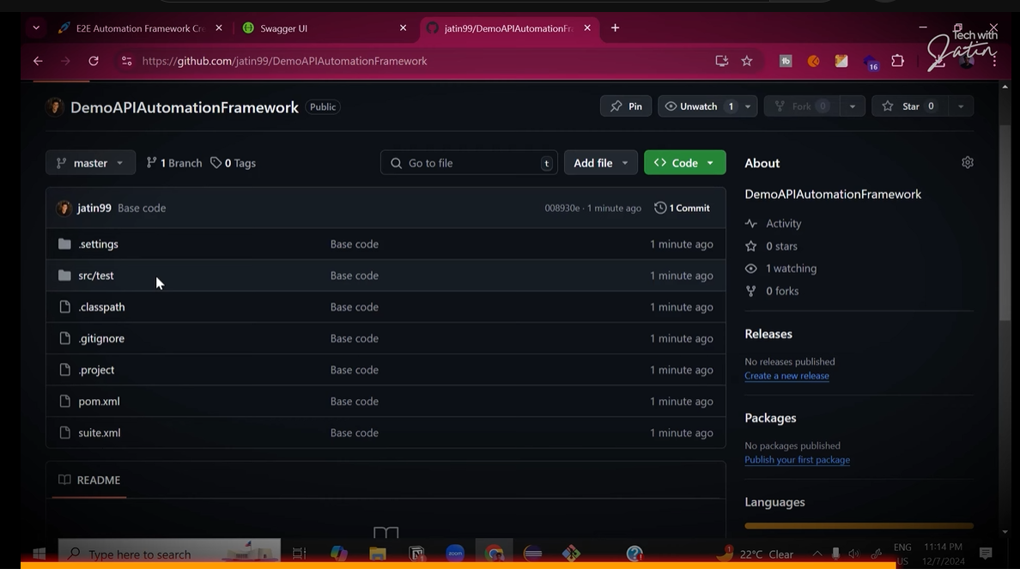

Now we have to do clcd pipeline

Click on Action tab

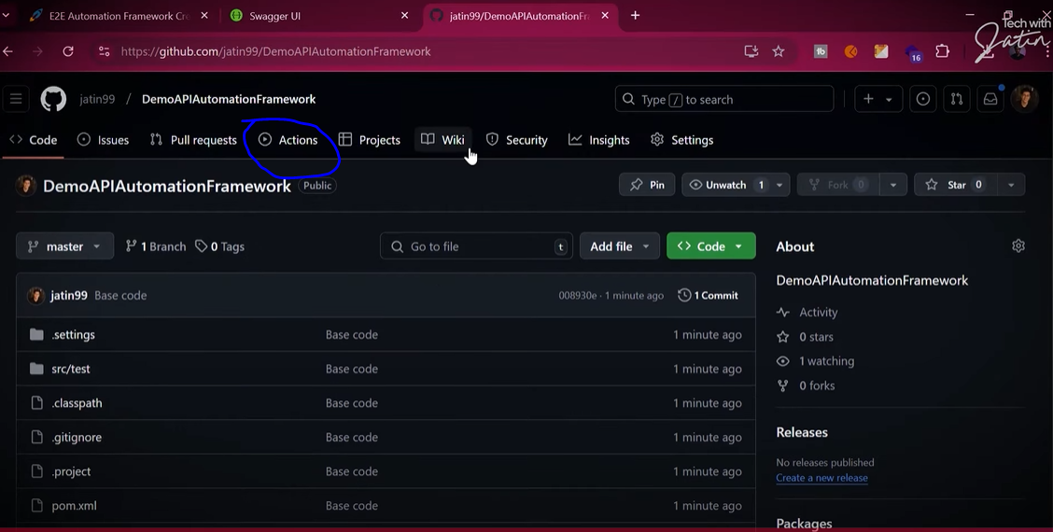

Search java maven

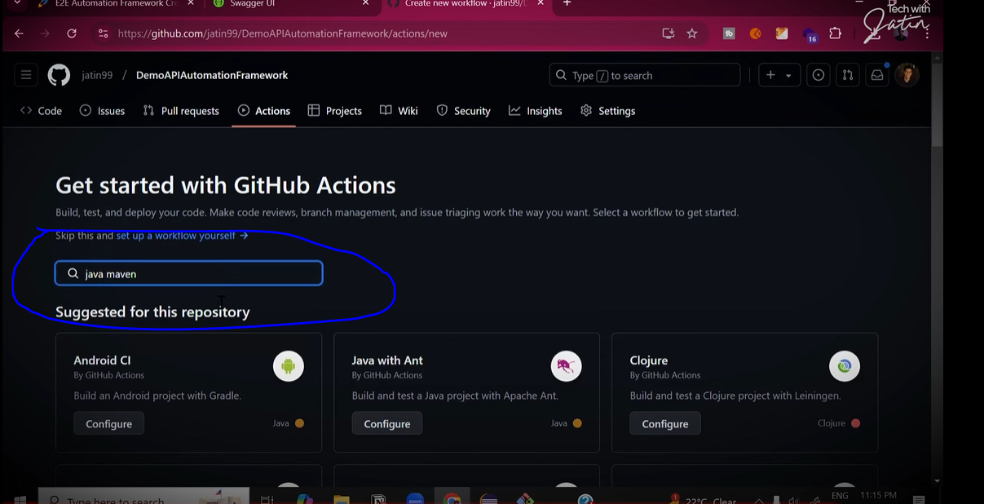

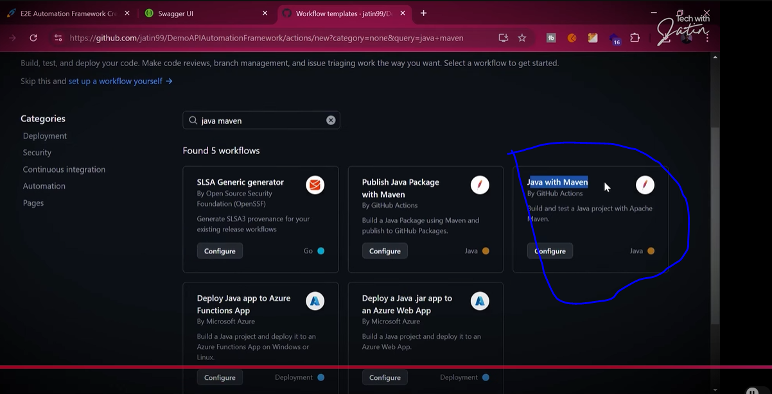

Remove this things

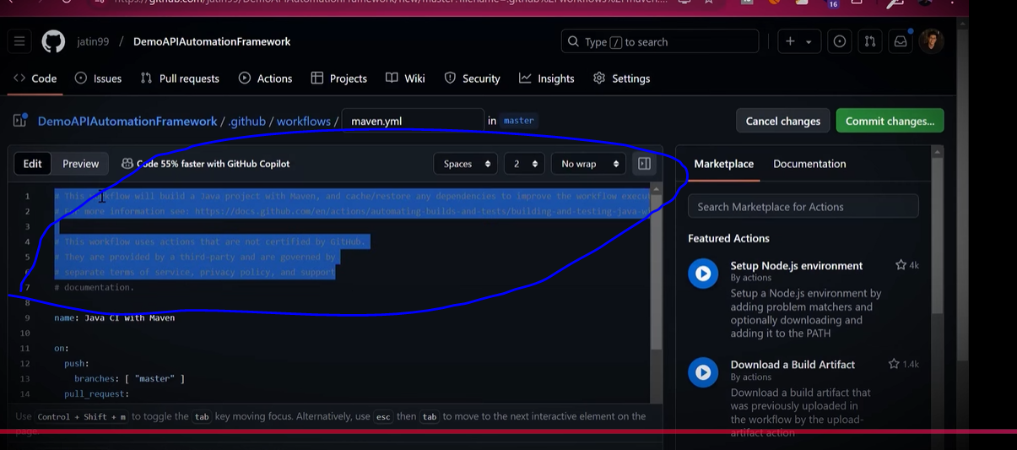

Then give the name (Like : API testing framework)

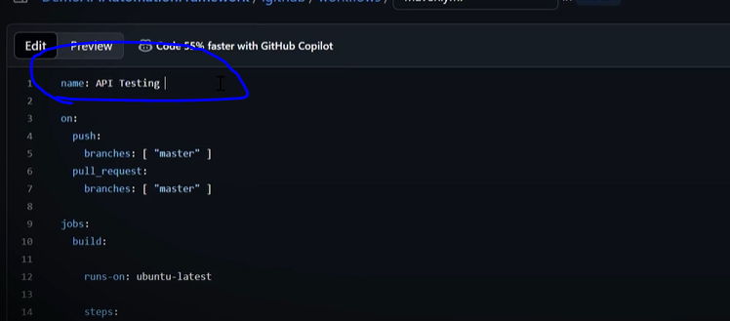

Change java version

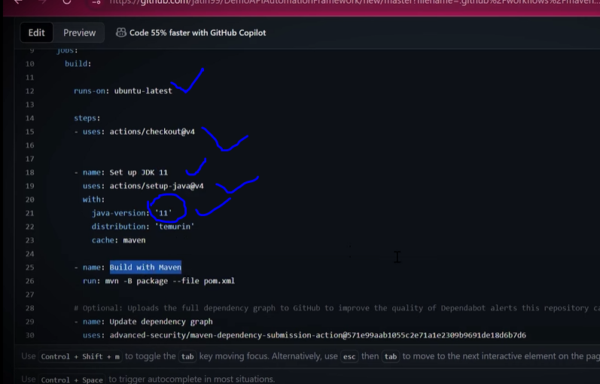

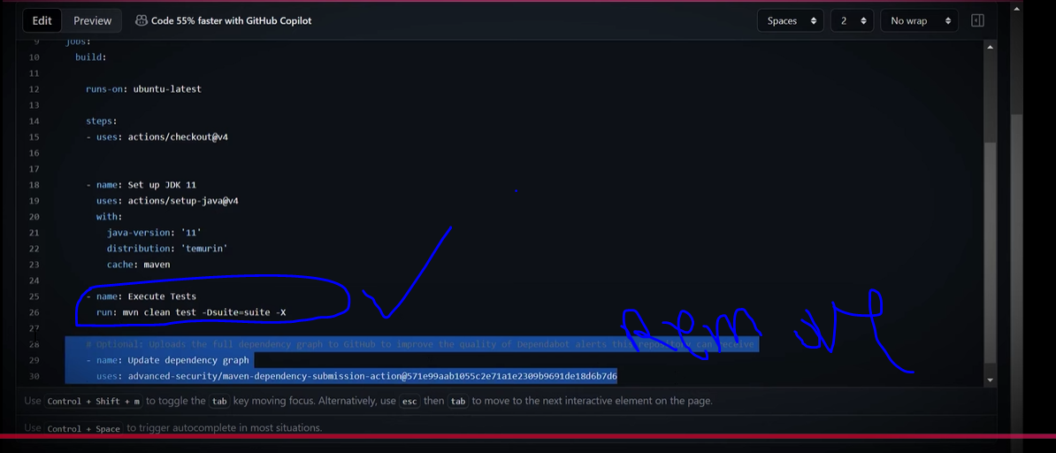

For above

Name: Execute tets

Run: mvn clean test –Dsuite-suite-x

Then click on commit

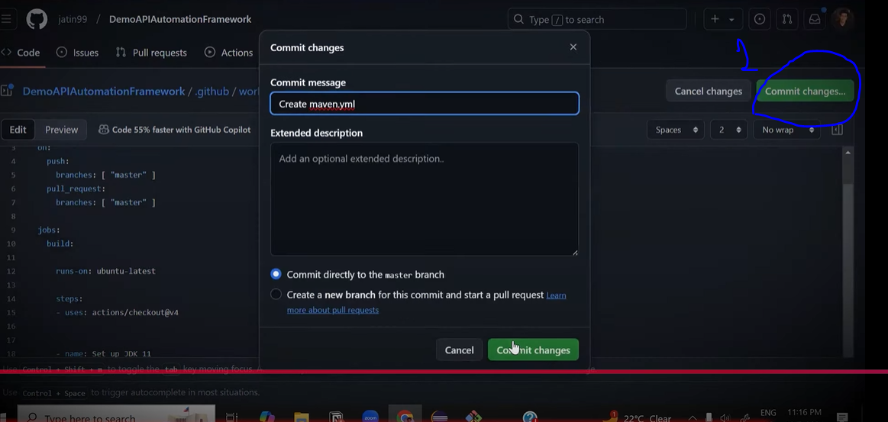

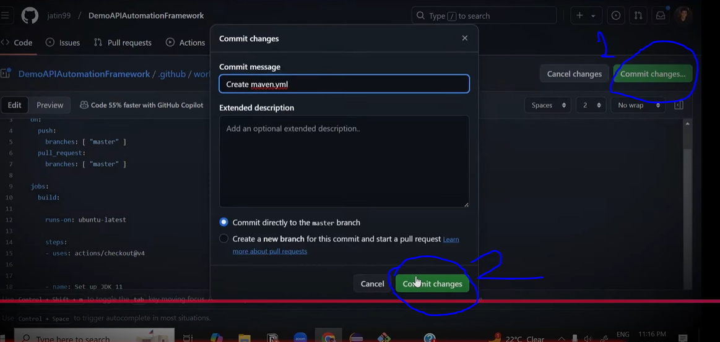

Click here

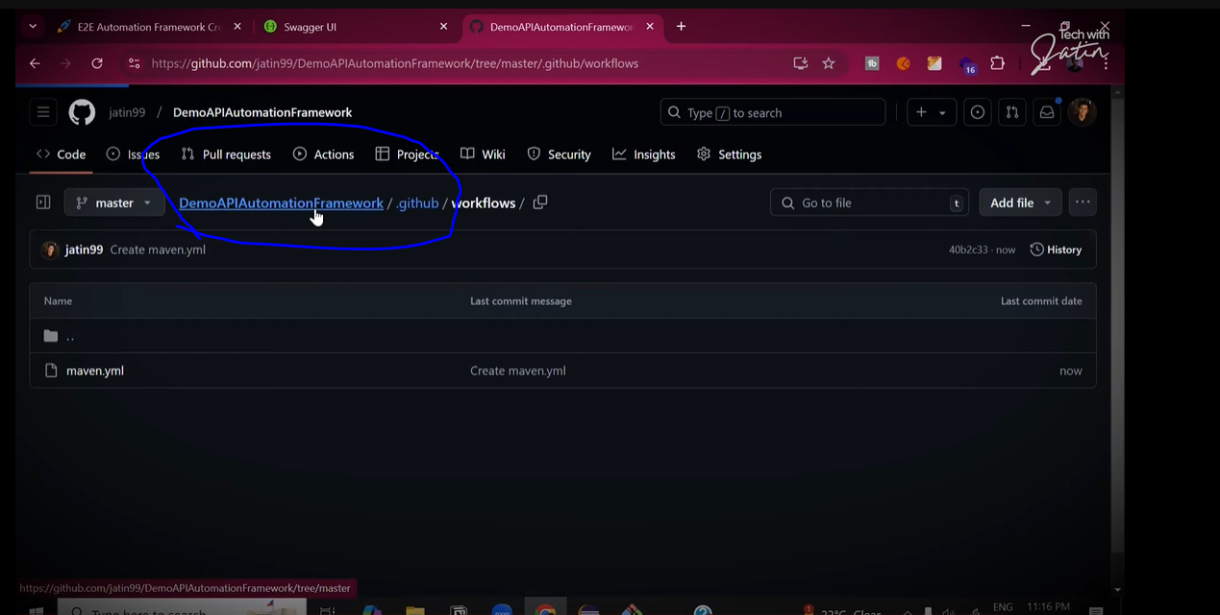

After that again click on Actions

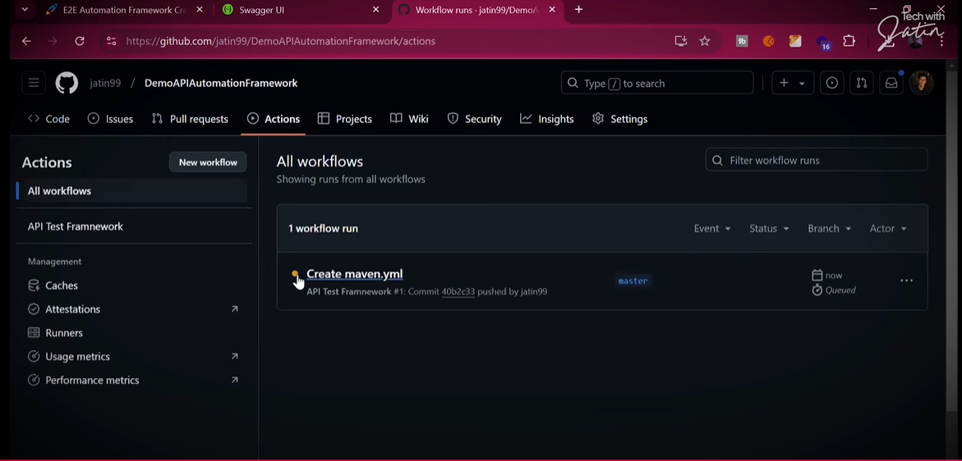

Click on

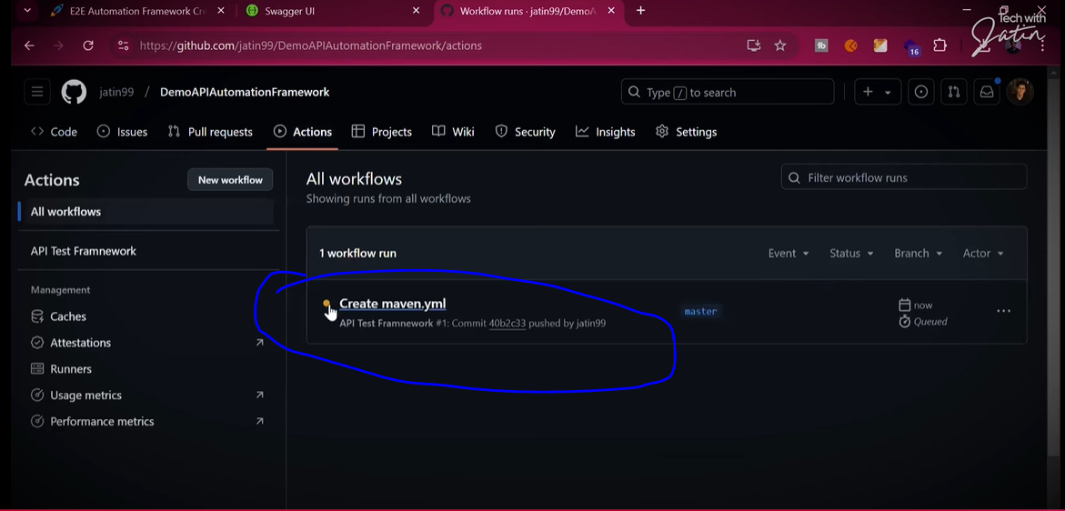

Click on build

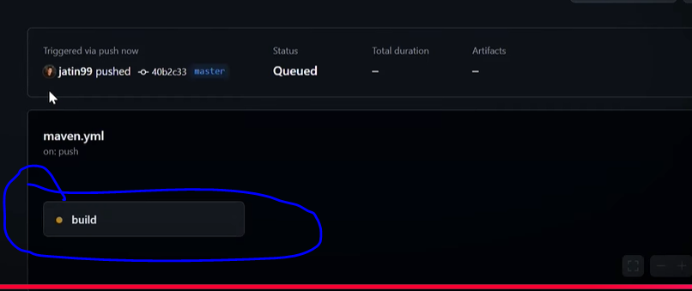

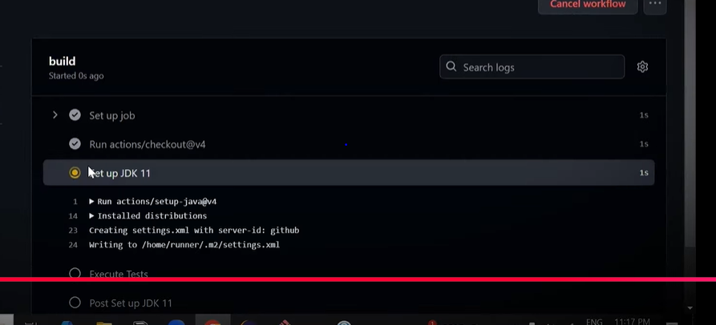

Scroll down the page

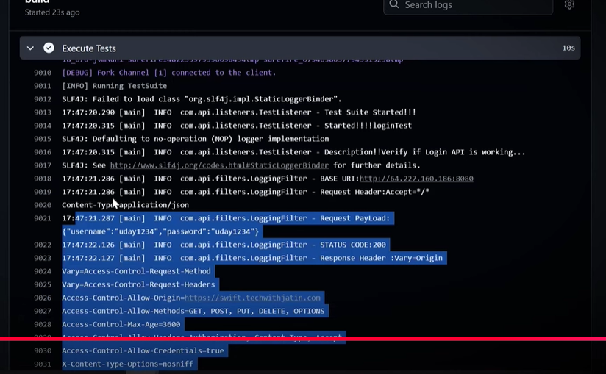

Now we have to setup the cron for time base testing

For creating the cron you knoe time type like UTC and IST. Github support UTC so u have to first convert time in UTC.

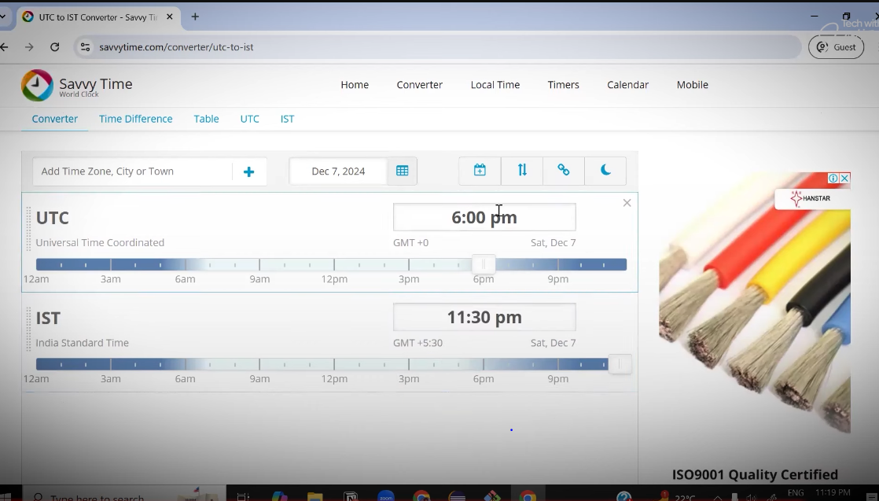

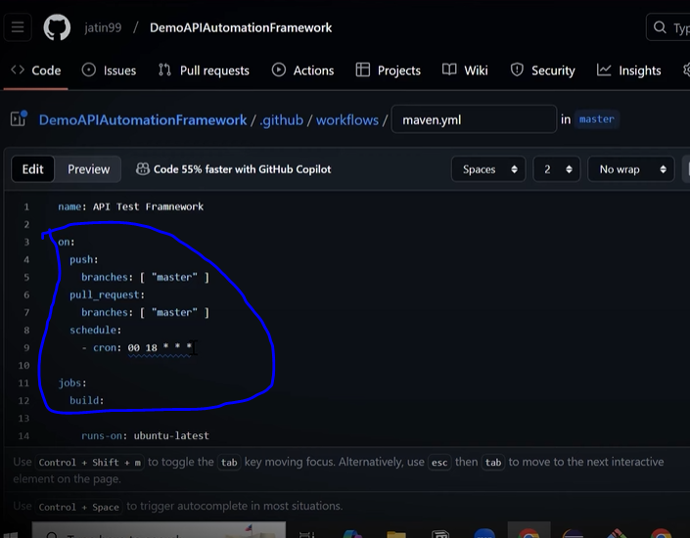

We can able to set multiple crones

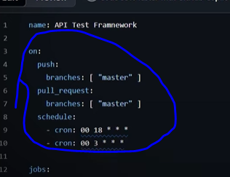

Next things is archive reports

So on the same screen in rightside there is marjetplace and select the ‘uplad the artifacts’

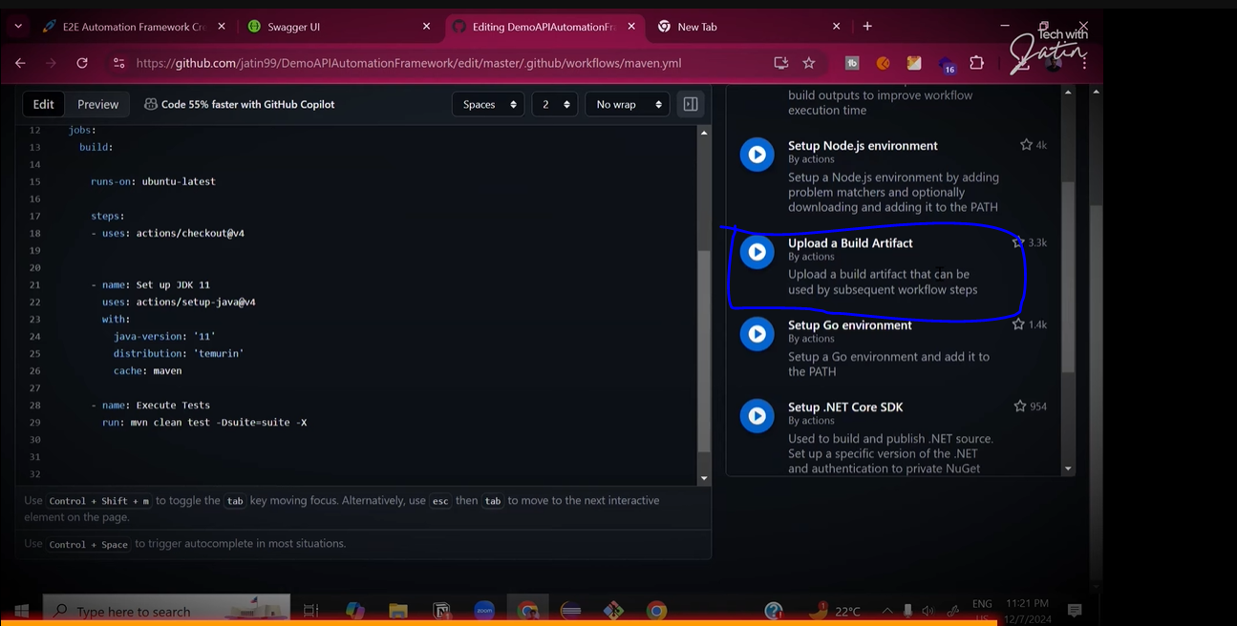

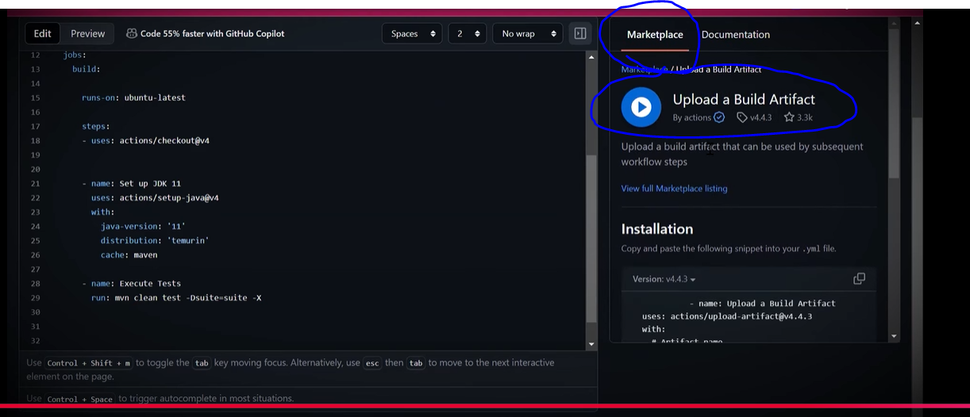

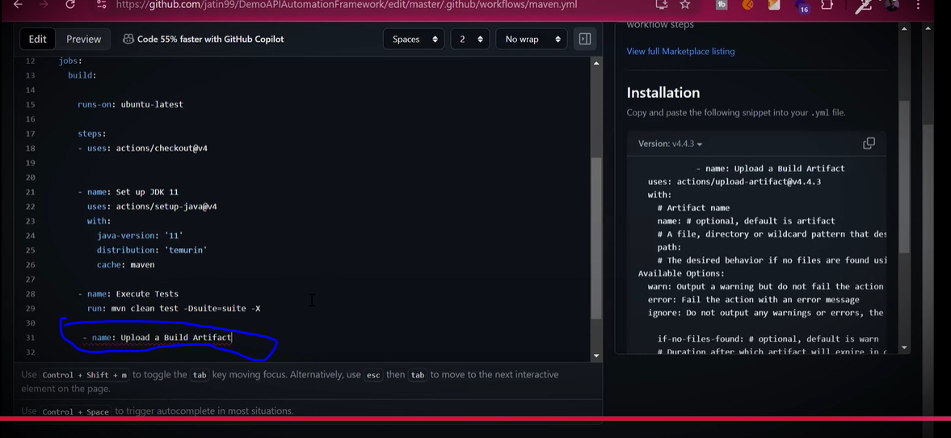

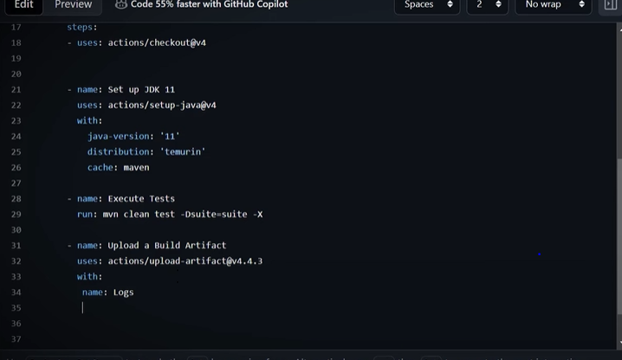

Now we have to fiven path of logs folder of our eclips maven project logs folder.

So go to the eclips

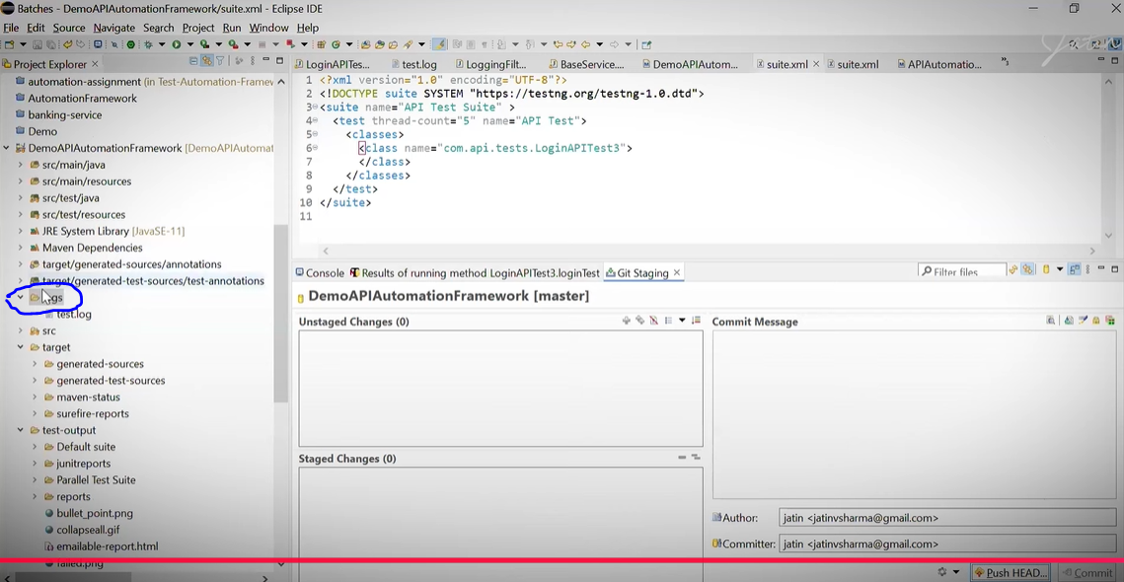

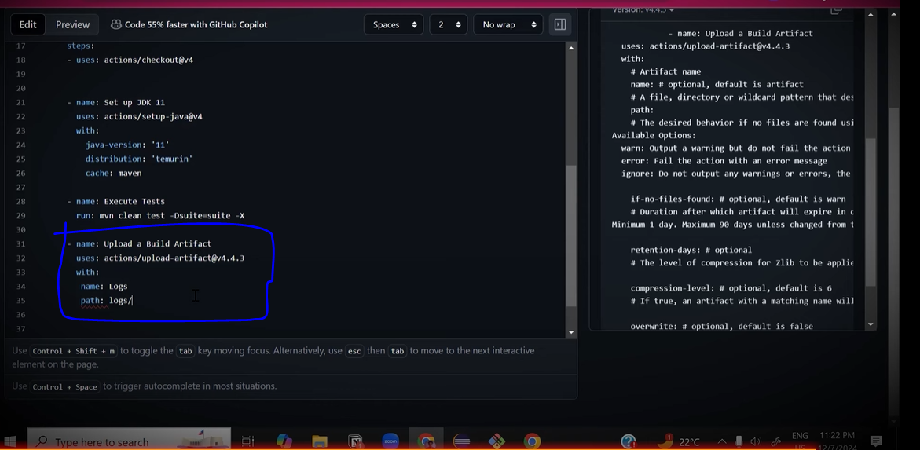

Its going to archive logs for us,

Now we have to comit the changes

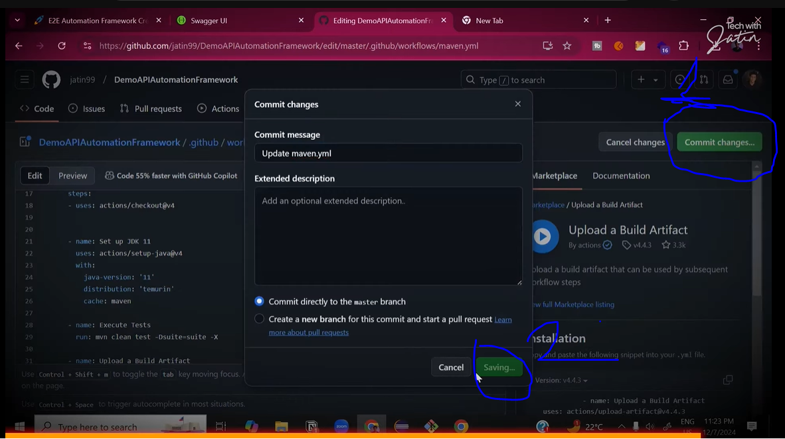

Then refrest the page

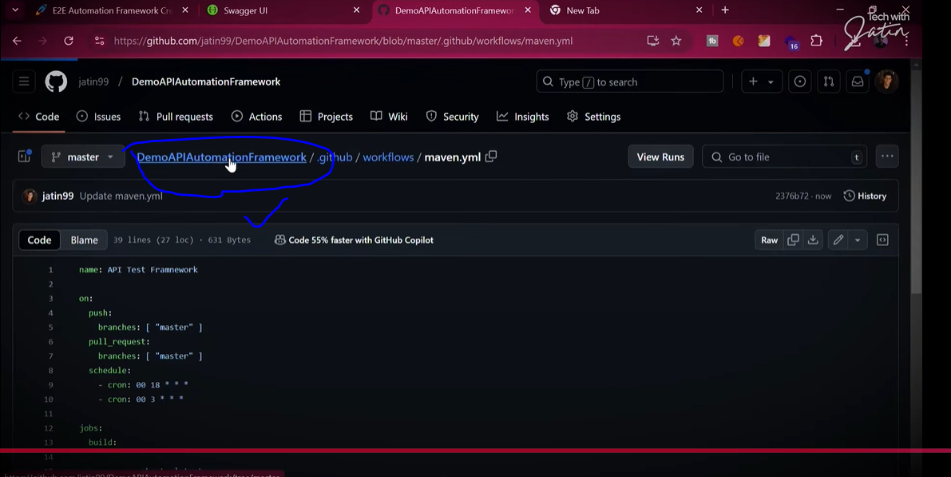

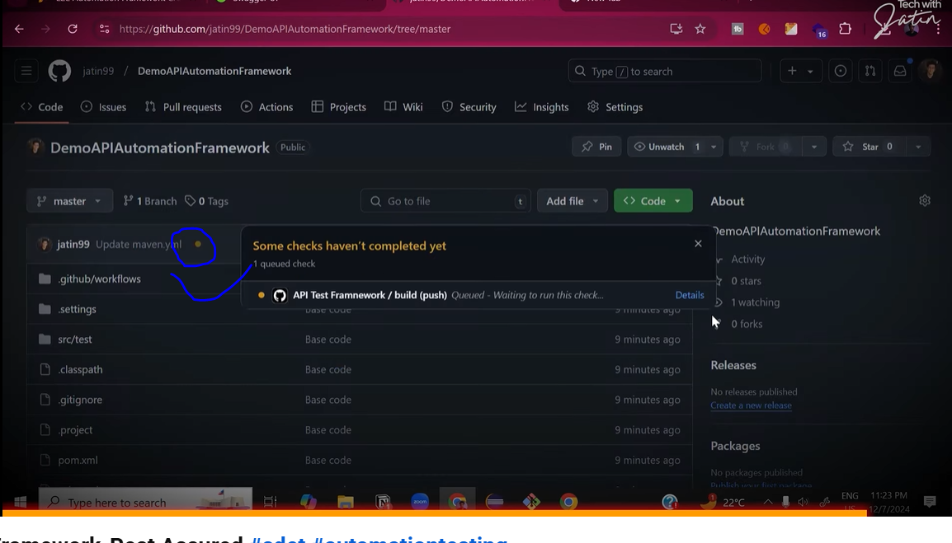

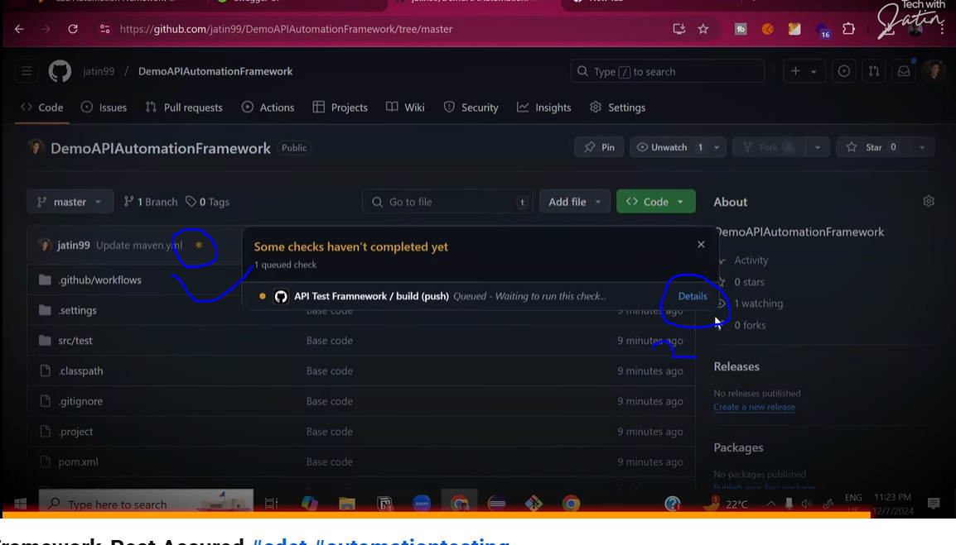

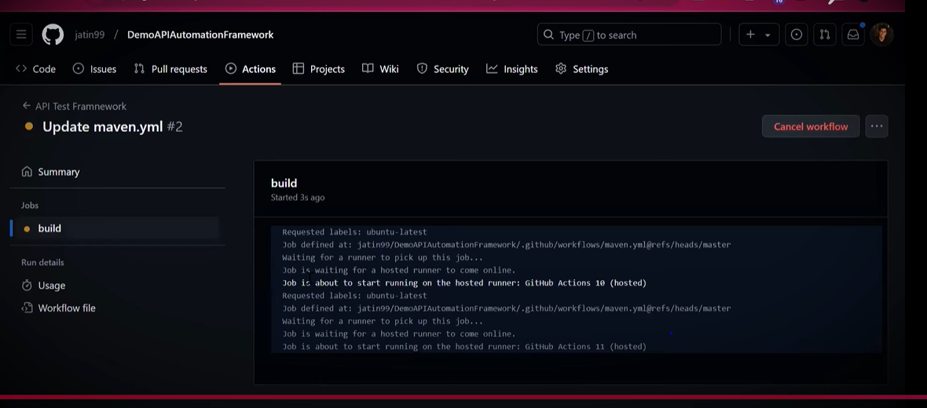

Runnung it again one more time (need to confirm where he is clicked)

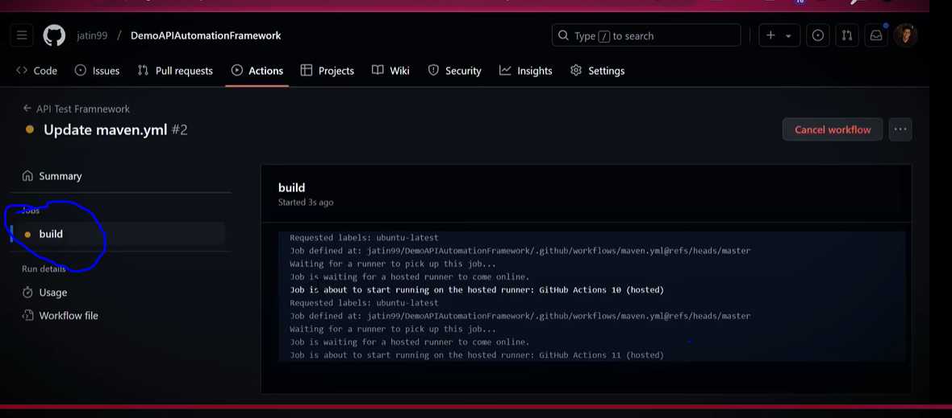

(I thing he click on build)

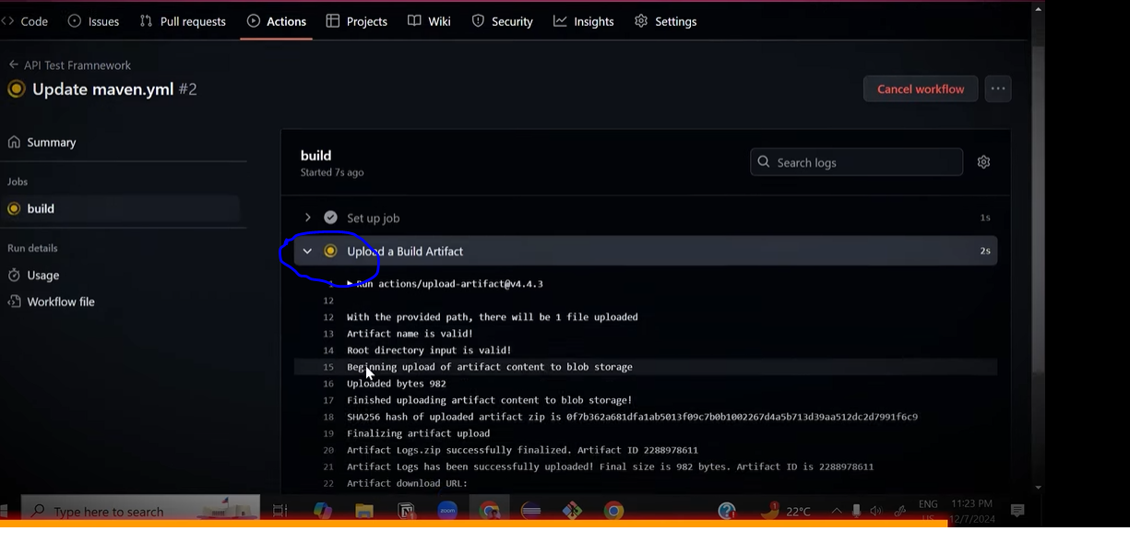

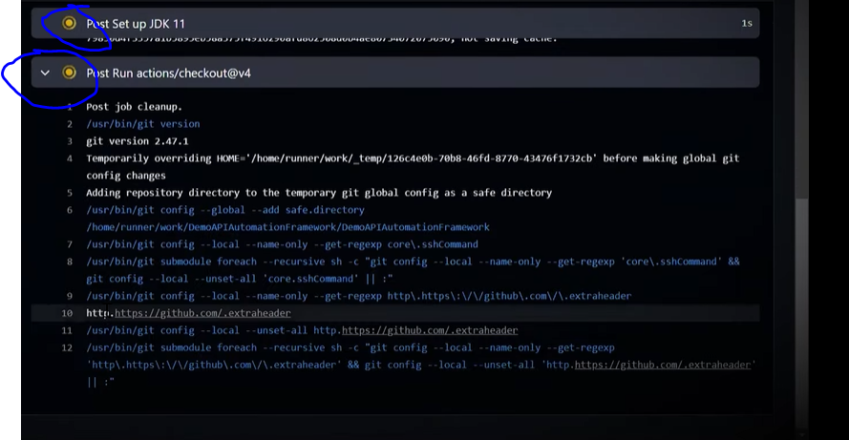

Go back to the framework

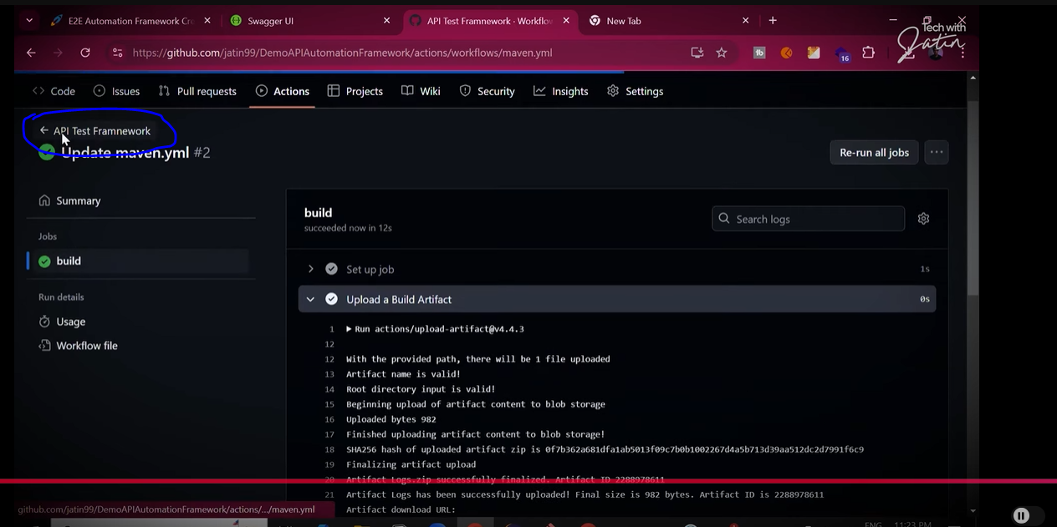

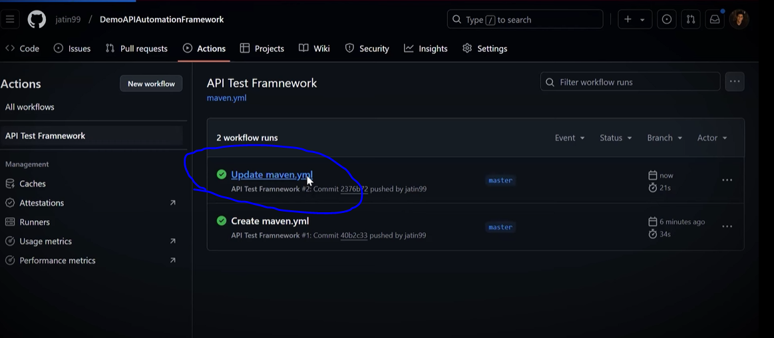

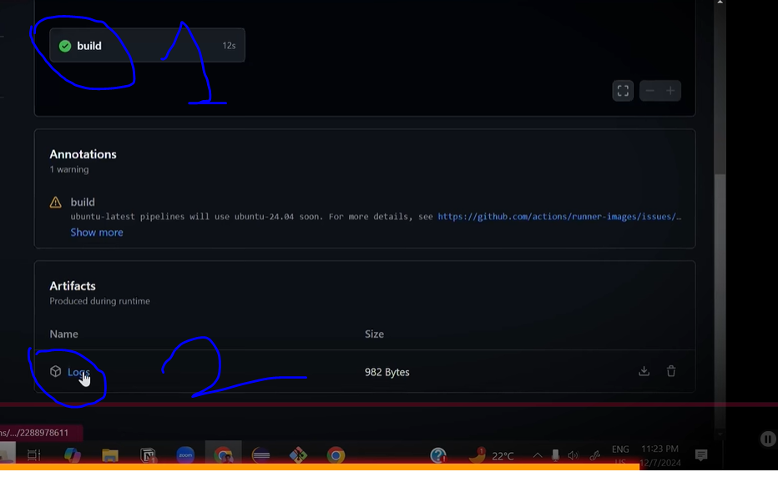

Download it

Open it

Now going to add action for publishing report

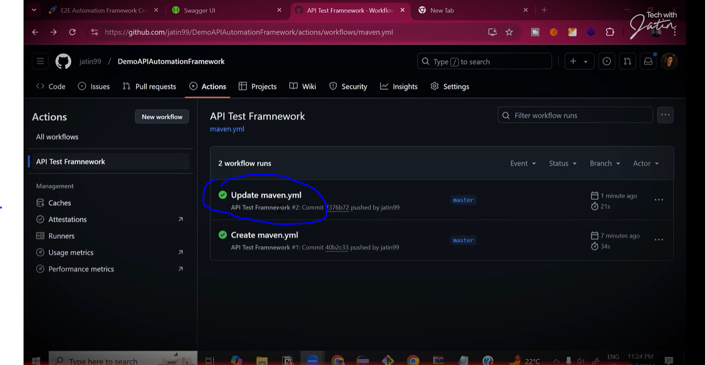

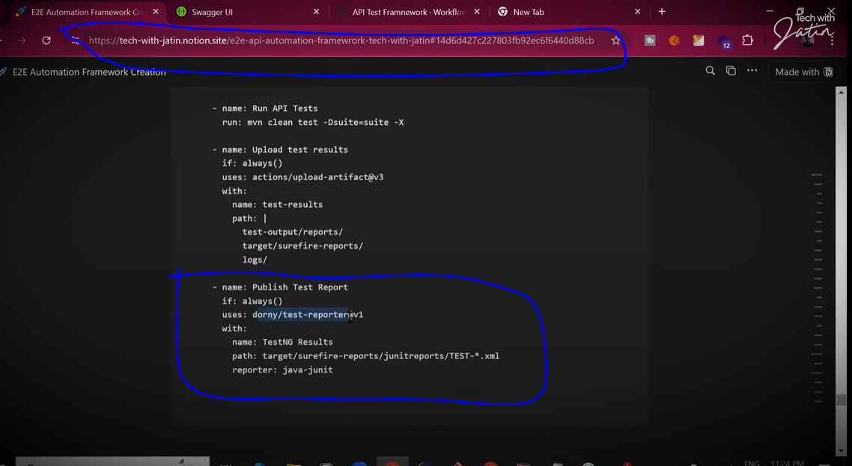

Copy above selected

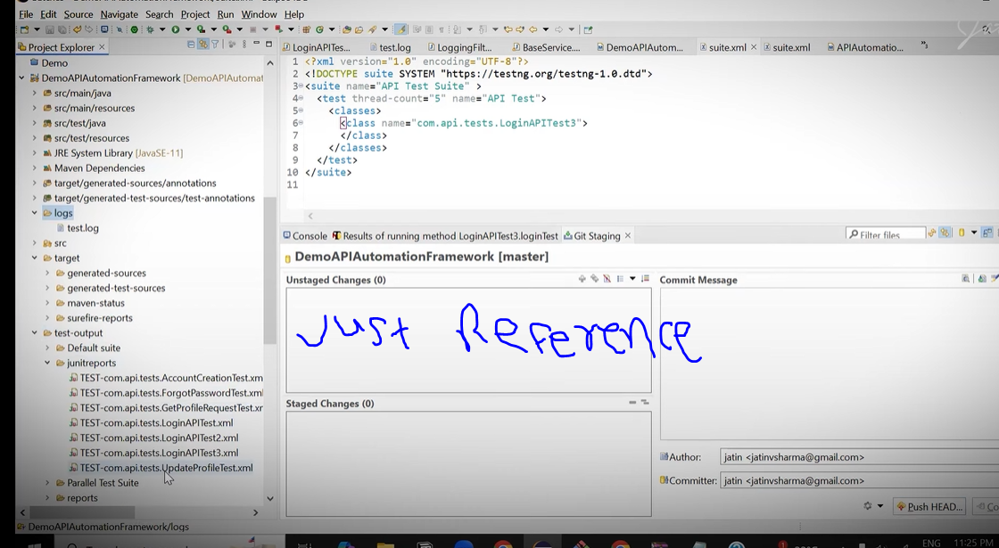

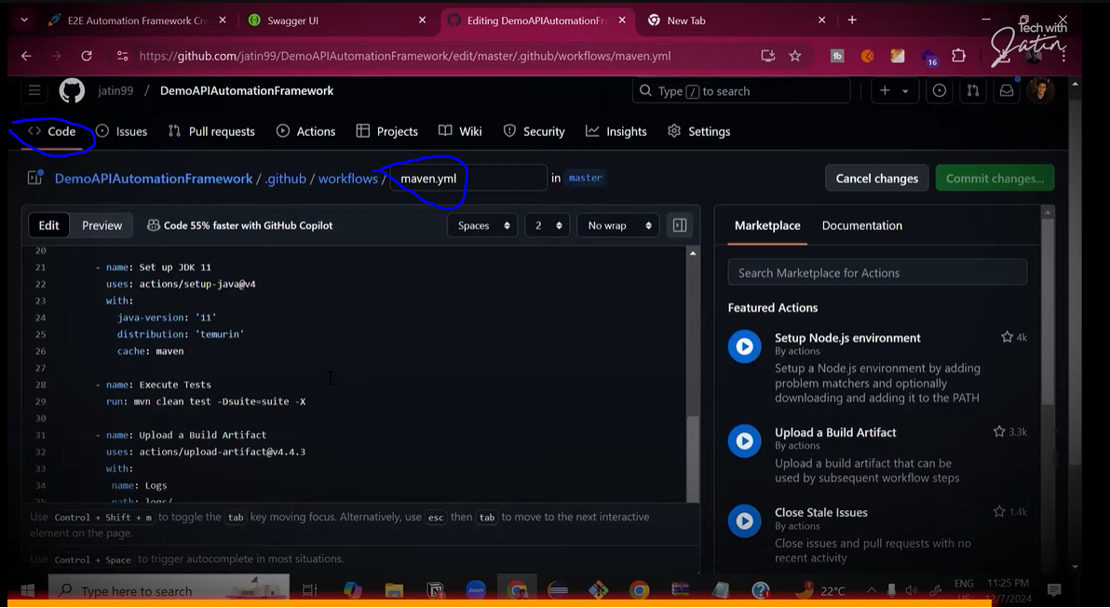

Past is last

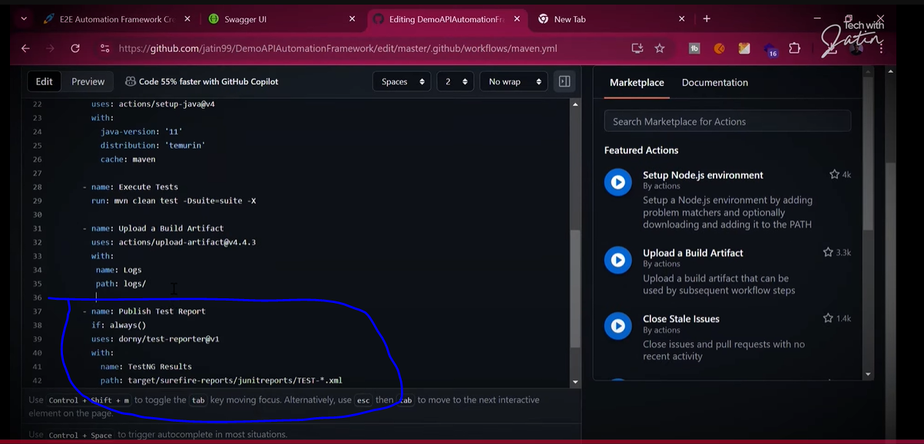

Now giving the permission

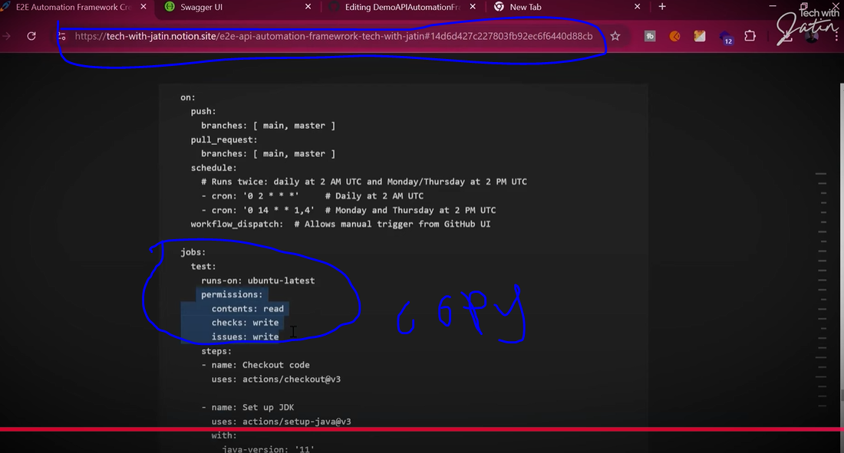

And past after the run-on section

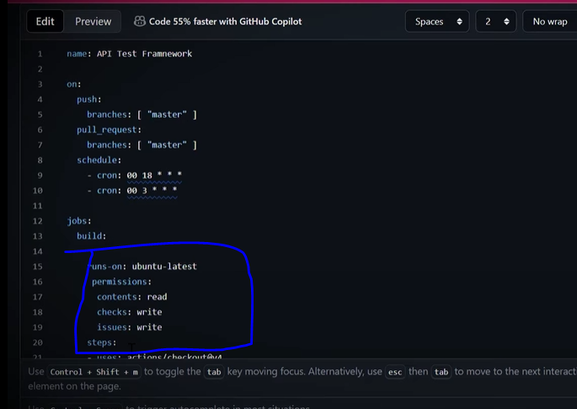

Again commit the changes

